**Growth Cone Analyzer**

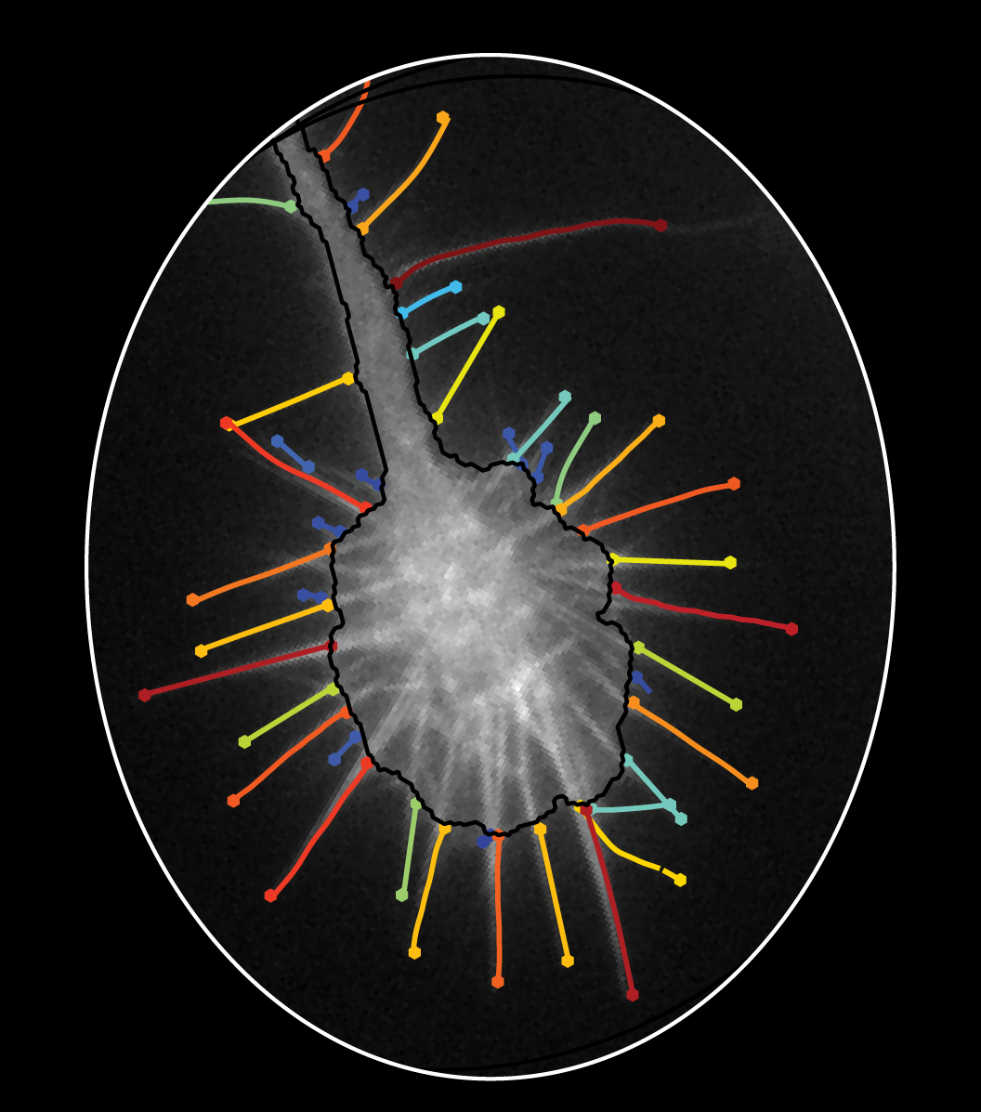

# Getting Started

## **Where are the help files and practice data/images?**

In the GCARelease go to the helpFiles folder

## **Matlab toolboxes required**

|  |
| --- |
| ‘Curve Fitting Toolbox’  ‘Image Processing Toolbox’  'Optimization Toolbox' |
| 'Parallel Computing Toolbox' |
| 'Partial Differential Equation Toolbox' |
| 'Signal Processing Toolbox' |
| 'Simulink Design Optimization' |
| 'Statistics and Machine Learning Toolbox' |
| 'Symbolic Math Toolbox' |
| 'System Identification Toolbox' |

## **Setting the Matlab Path**

Matlab needs to be able to find the .m files (ie functions) called in the workplace

To set the path manually, right click on the folder you want to

add to the path.

**Select:**

**Add to Path**

**Select Folders and Subfolders**

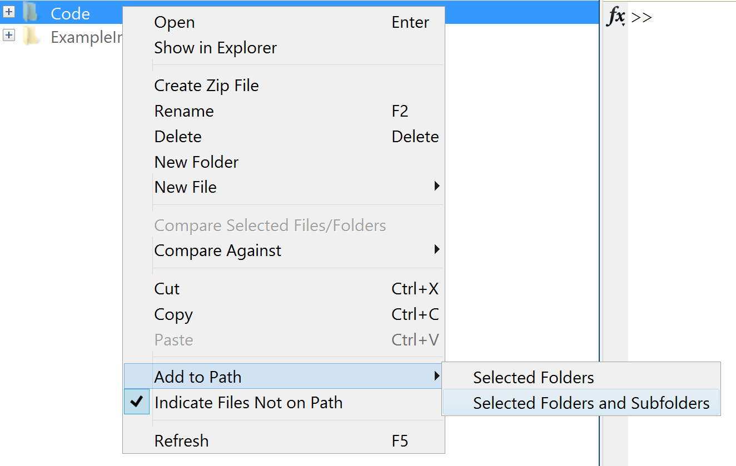

Note I: Files which are not on the path will typically be grayed out when viewed in the Current Folder window of Matlab.

Note II: If you try to run the main GCA function and get the below error, your path was not added successfully.

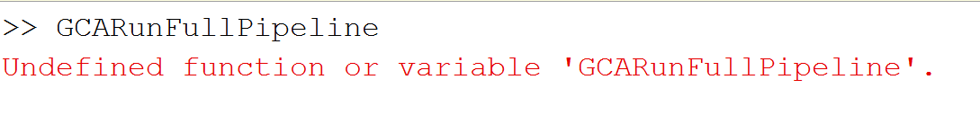

## **Preparing your data for GCA Analysis:**

### GCA Input

**GCA requires a ‘Channels’ folder with a list of .tif files for each channel as input. (See below format for a single channel)**

**The names of the folders are flexible:**

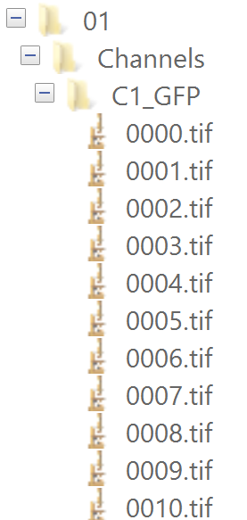

GCA includes a data preparation function to help the user prepare their data, starting from a directory of compressed .tif movie files.

If possible we recommend .tifs be named such that each movie follows the below format.

*KDGroup_Date_CellID_ChannelID.tif*

*While not necessary, this facilitates the automated downstream group analysis organization.*

We include a small CroppingExample folder that details how to use GCA’s prepare data tool.

Alternatively, one can use ImageJ for cropping and data prep.

However, we found the GCAPrepareDataPerformManualCropping tool more expedient when there are many images to process.

### I_Data prep(cropping)Tutorial

Download the example images in helpFiles/I_DataPrepTutorial/ExampleStackDir

**Type in the command line:**

**GCAPrepareDataPerformManualCropping**

**STEP I: Load stack directory path**

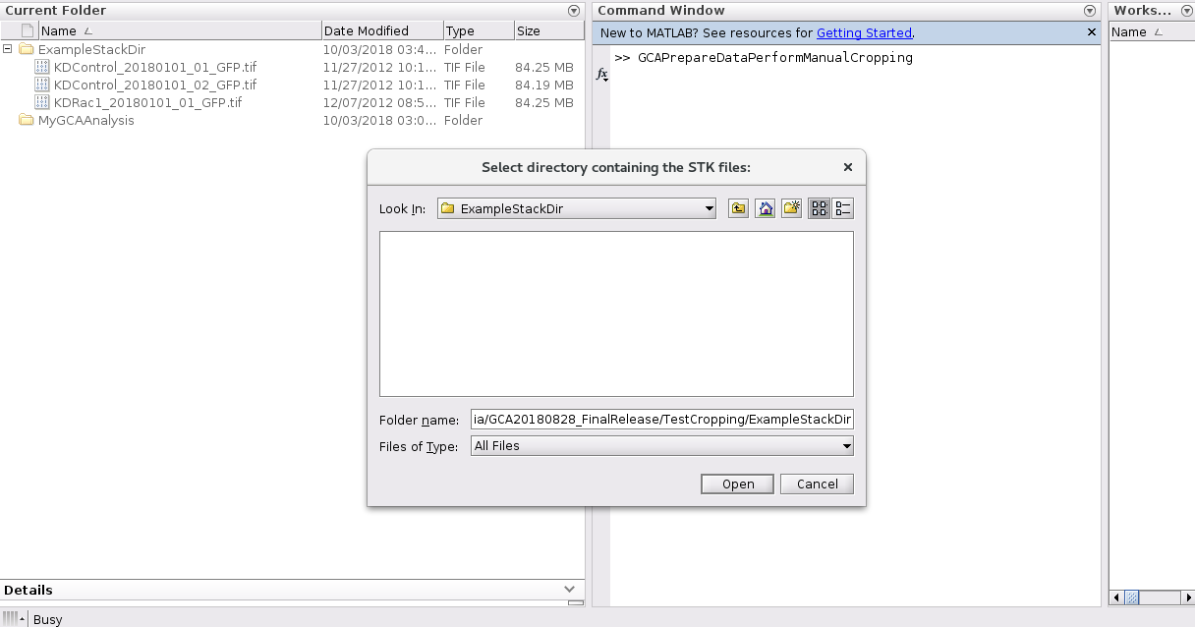

**STEP II: Select an output directory**

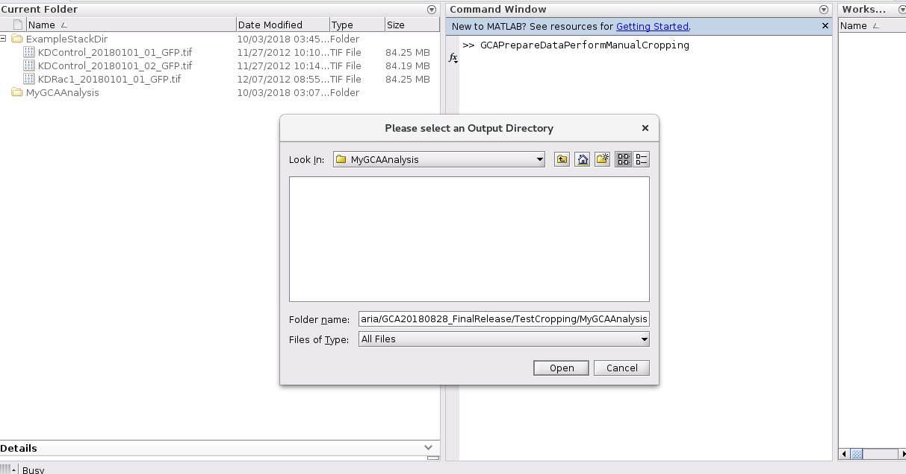

**STEP III: View movie and skip if you do not want to analyze.**

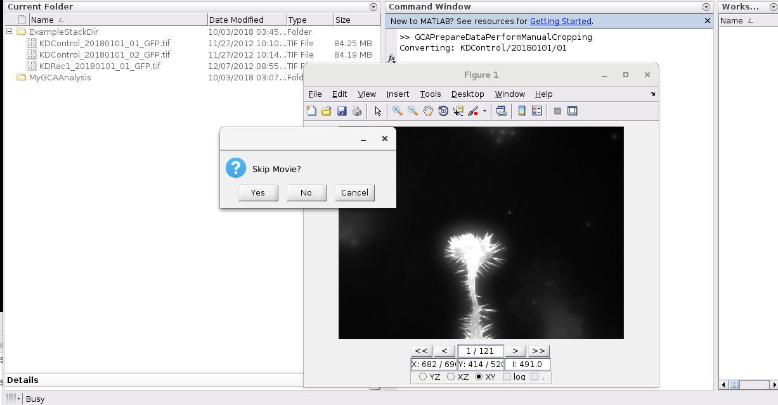

**STEP IV: Crop the Image**

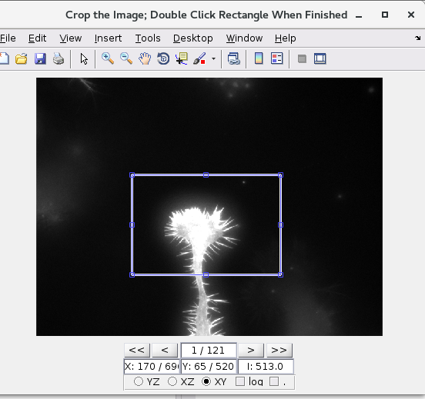

**STEP V: Use the arrows to scroll through your movie and make sure the cropping is correct for all frames.**

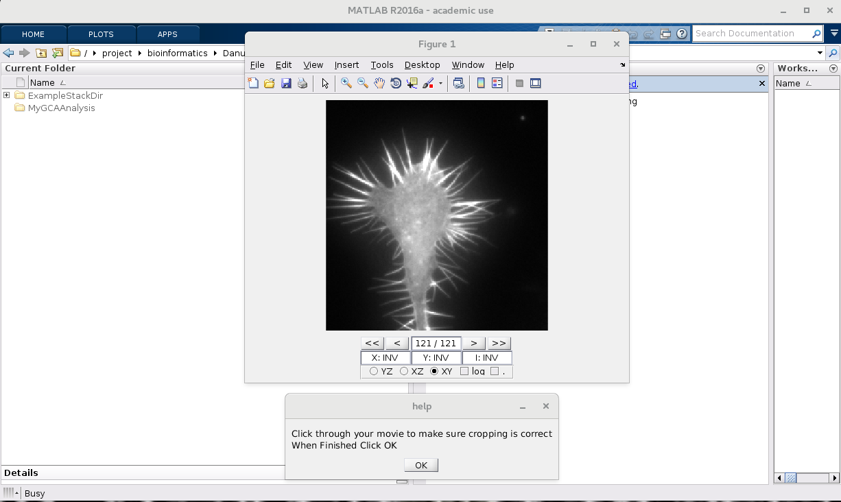

**STEP VI: Re-do cropping if necessary**

**STEP VII**: **Crop another region if desired.**

*(If no it will load the next image in the stack directory: repeat above steps)*

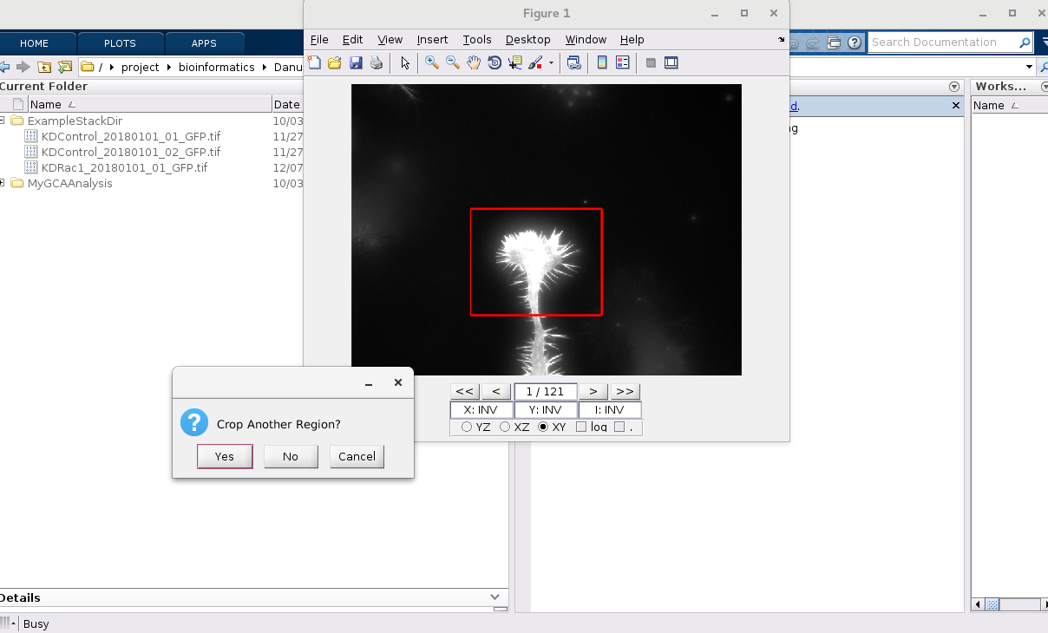

**Step IV: While we only used one growth cone per image in the manuscript, below shows how you can crop a second region.**

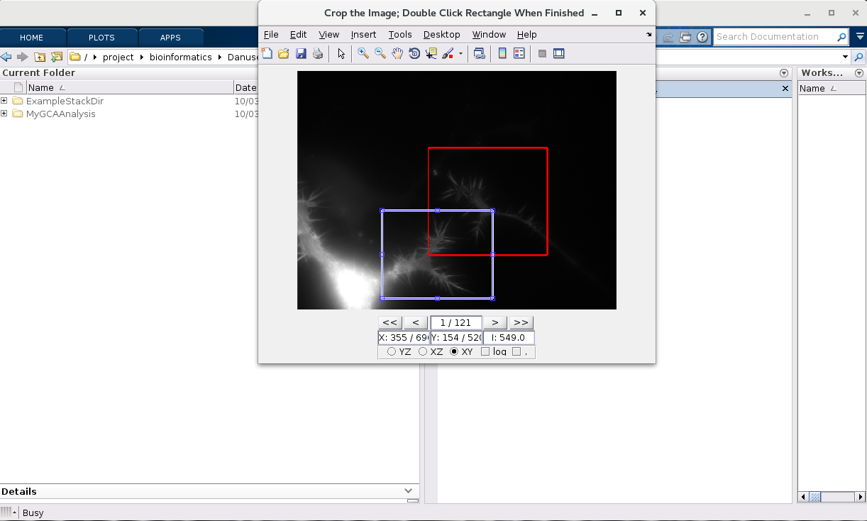

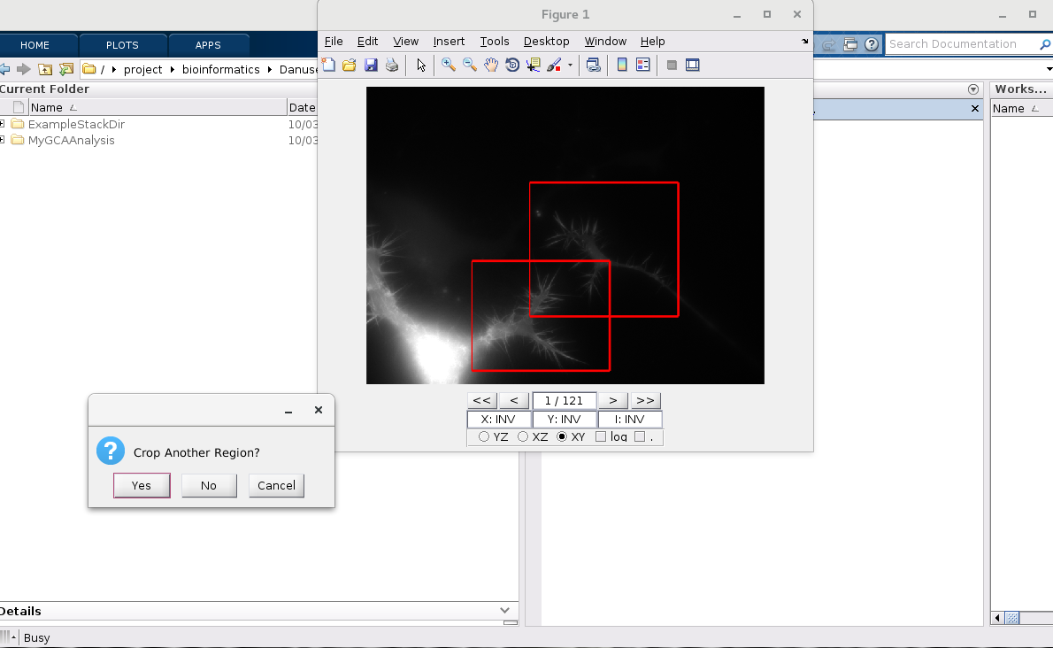

**Etc….**

**Example Output:**

*Below shows the final prepared data for our test examples.*

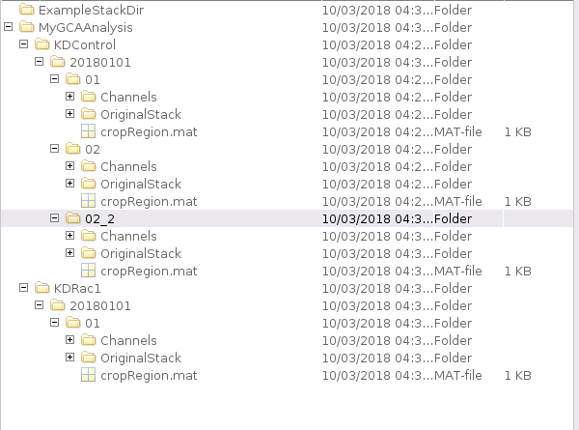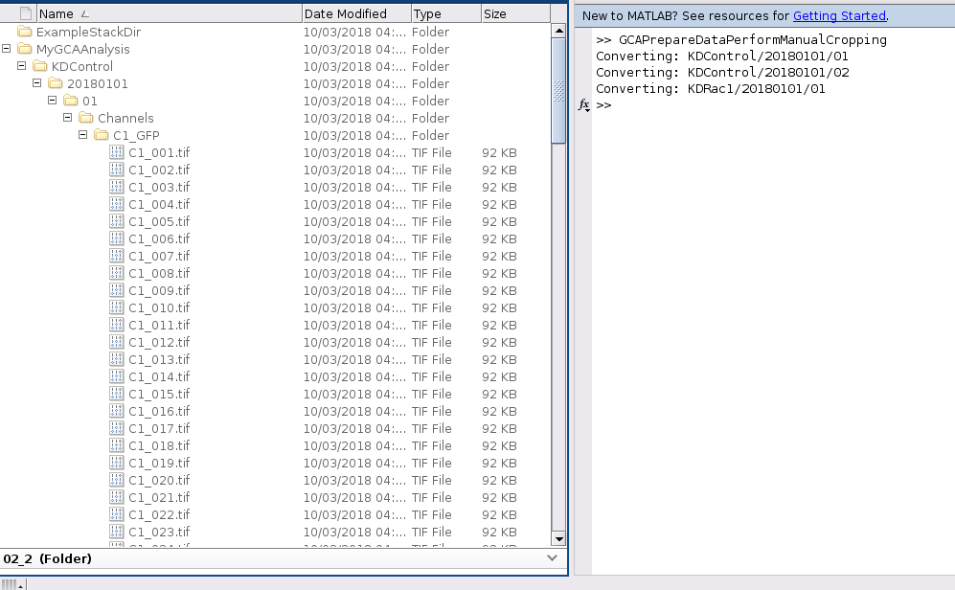

# Running GCA

## **Example Segmentations: From Manuscript**

We provide several images/GCA output examples corresponding to a diverse range of cellular systems and imaging modalities tested in our manuscript.

While many of the segmentation parameters were conserved, each set of images includes its own parameter.m file detailing any changes

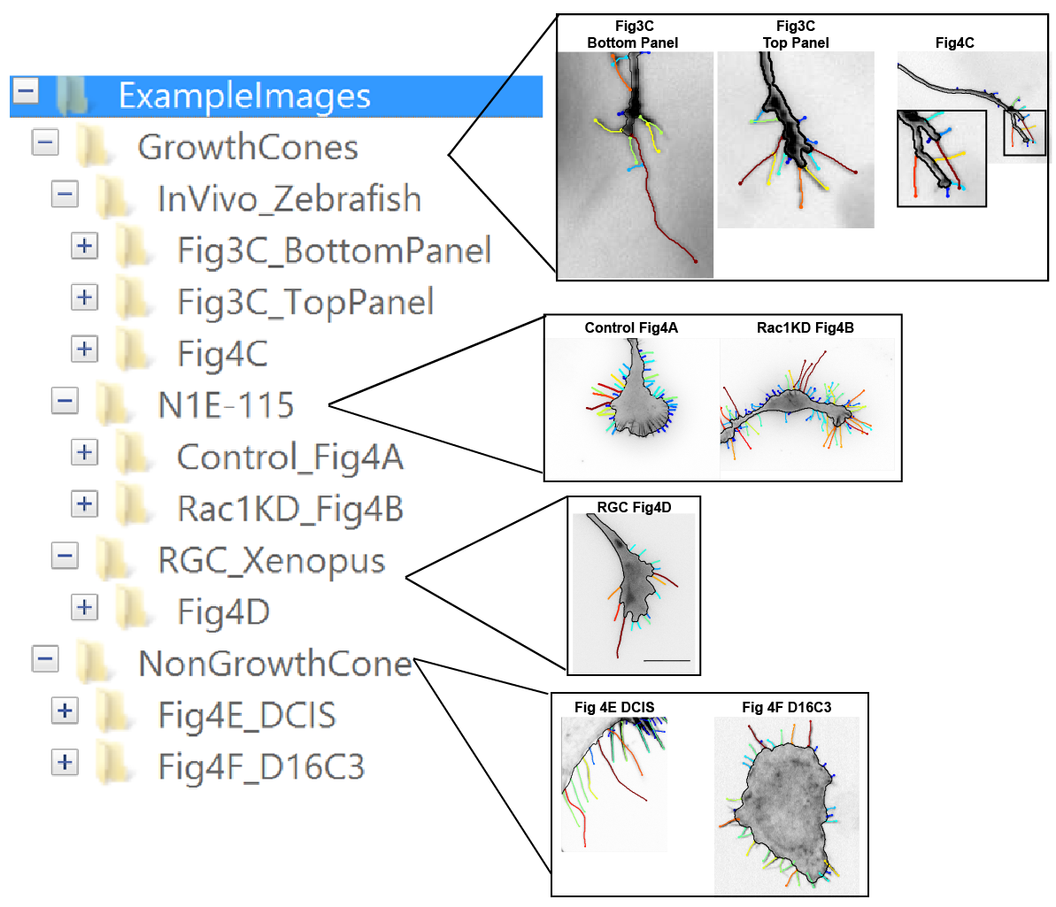

## **II_GCARunBasicPipelineTutorial**

**Choose one of the example files from:** *helpFiles/I_GCARunPipelineTutorial/*

(Note: these examples only include several frames to speed up testing.

Therefore, we only flag it to run veil dynamics and neurite outgrowth state partitioning for acutely treated CK666 growth cone movie in the ***N1E-115_Perturbation***directory).

**To Run GCA:**

Type **GCARunFullPipeline** into the Matlab Command Window and press enter:



*Note: If get the below error, the GCA Code needs to be added to the matlab path:*



*See section:* *Getting Started- Setting the Matlab Path*

**By default, the function will prompt the user to specify 2 files:**

**I) A Channel Directory (Includes a list of .tif files): Below shows example**

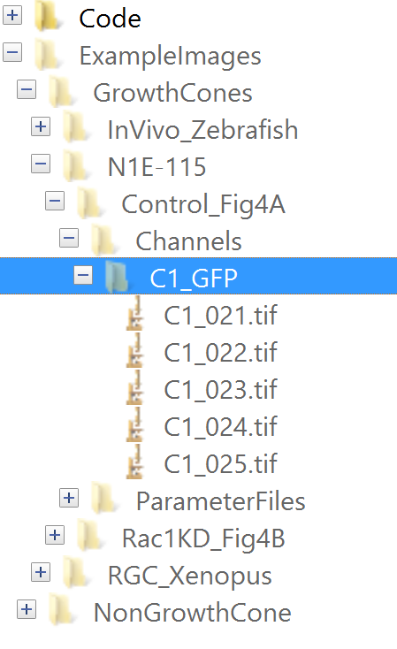

**II) A segmentation parameter.m file**

**(Allows the user to more easily manipulate segmentation and other parameters)**

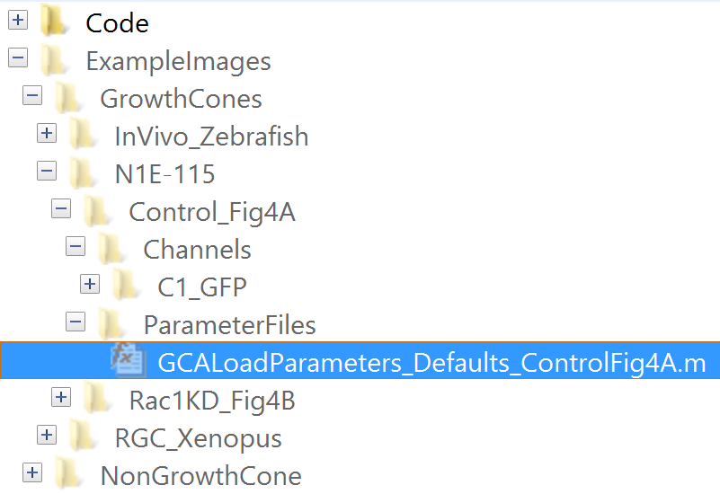

**Alternatively, you can enter any of these path/ file names directly as input**

**Type:**

**GCARunFullPipeline(‘ChannelDirectory’, ‘myPath/Channels/C1_Flouro’, ‘parameterMFile’, ‘myPath/GCALoadParameters_myParams.m’);**

**(Note: GCA functions mainly utilizes the *inputparser* in Matlab**

**See:** [**InputParser Matlab**](https://www.mathworks.com/help/matlab/ref/inputparser.html;jsessionid=e8da7eaf92d0a62ed1065c239181) **link for more details.**

### GCA Output:

By default, GCA will make a new **GrowthConeAnalyzer** directory two folders up from the input channel directory (in our case …/C1_GFP)

The output for the full default pipeline is organized as below:

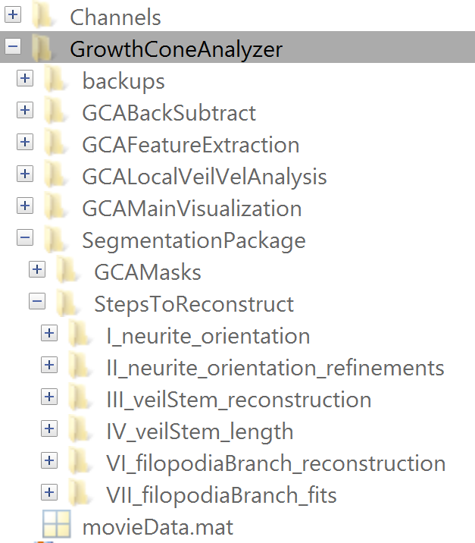

#### Output: Segmentation Steps (Growth Cone Movie)

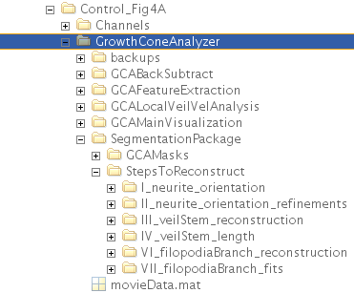

***Note each of the major segmentation steps is marked by its own folder.***

By default GCA will run the primary TSOverlays (ie Troubleshooting overlays) for each step and these images will be plotted in the corresponding folder.

(One exception is Step VII- as making ALL plots for each individual filopodia fit is very computationally time consuming- therefore we recommend using *GCAInteractiveExamineFilopodiaFit.m* function discussed in the *Troubleshooting Filopodia Fits* section below to visualize/save plots of fits corresponding to specific user-selected filopodia.

**For more information regarding each step see the helpFiles folder:**

SegmentationParameters_TableS1.pdf

SegmentationWorkflow_FigS2.pdf

(colors above are the same as in these two figures)

#### Output: Segmentation Steps (NonGrowth Cone Movie)

Note that segmentation steps I, II, and IV, which help reconstruct the veil/stem of the growth cone and measure the neurite length, are irrelevant for non-growth cone images and thus these folders will not be made if the ‘nonGrowthConeImage’ parameter is selected

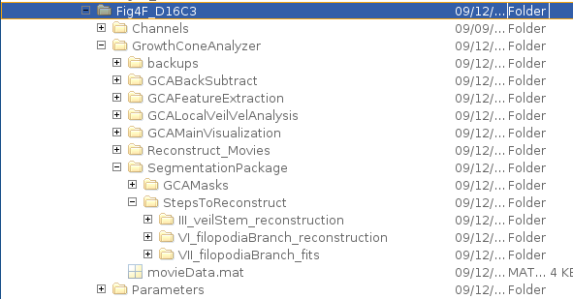

#### Output: Main Visualization

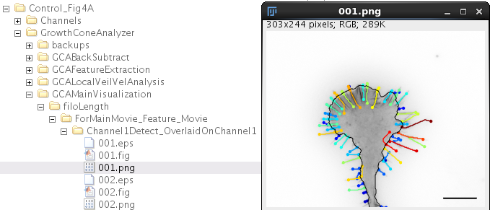

**By default GCA will plot the filopodia segments color coded by length.**

**If embedded actin bundles were detected, it will plot the full actin bundle lengths.**

#### Output: Feature Data

For each feature a .mat and .csv file will be generated

Each .mat file is organized as a nFrames x1 cell array

Each column of the .csv is a frame of movie and each row is a feature value.

See also: **Grouped Feature Extraction and Comparative Analysis Tools**

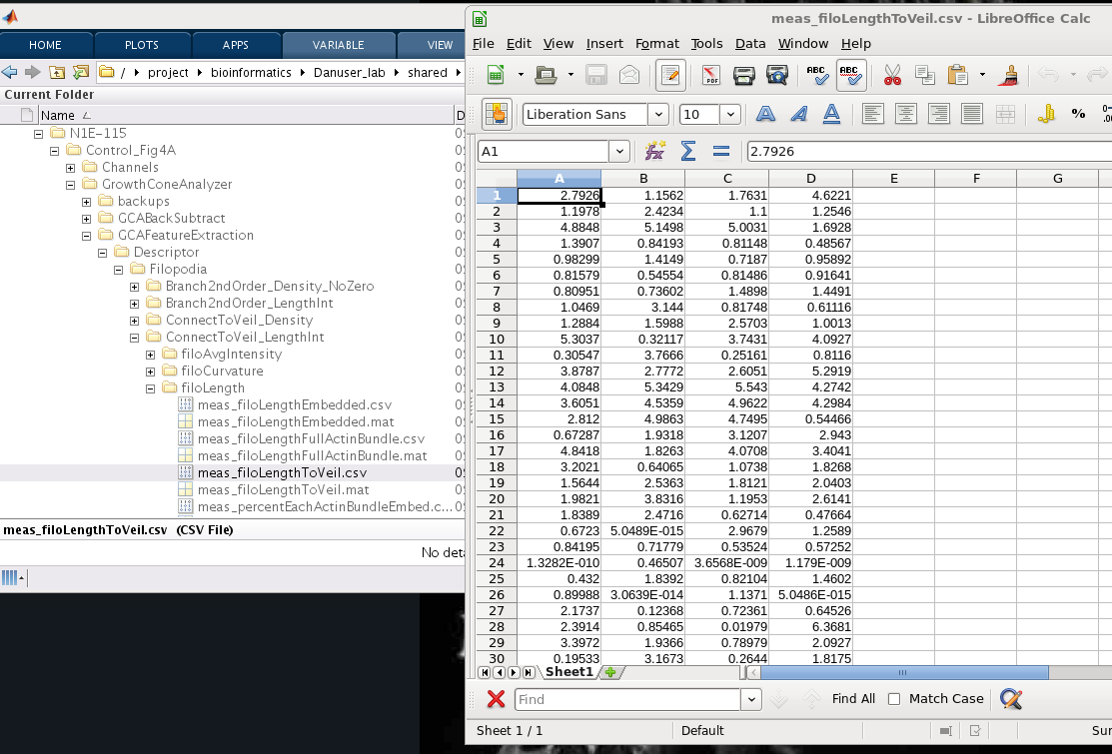

##### Organization of Feature Data

While the default organization of the feature data can seem a bit daunting there is indeed a reasoning behind this structure.

Features are separated into

Descriptors (Veil and Filopodia)

GlobalFunctional Features (i.e. Neurite Length)

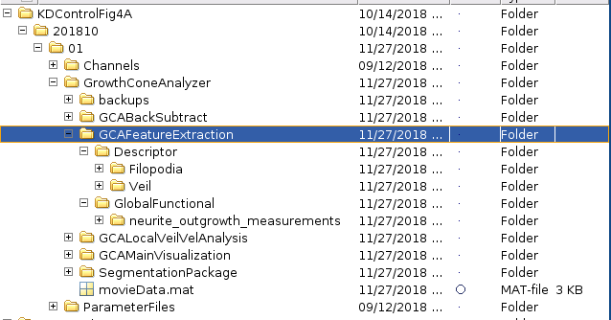

If you open the Filopodia folder the general naming structure is such that

Filopodia

Name of the Pre-Defined Filopodia Filter Used

Identifier of the GCAAnalysisExtract_Function Used

meas_*featureNameX*.mat

meas_*featureNameX*.csv

This folder structure should correspond to the AnalysisInput.mat file, which records the analysis extraction instructions specified for the given filopodia feature folder of interest.

(Note these instructions can be modified by an advanced user that would like to customize their own feature pipeline).

analIput is a 1xn structure where n is the number of analysis types specified (ie those extractions sharing a similar filopodia filter as indicated in the field .filterType).

For example 4 Filopodia Filter Types were specified in the below **AnalysisInput.mat**

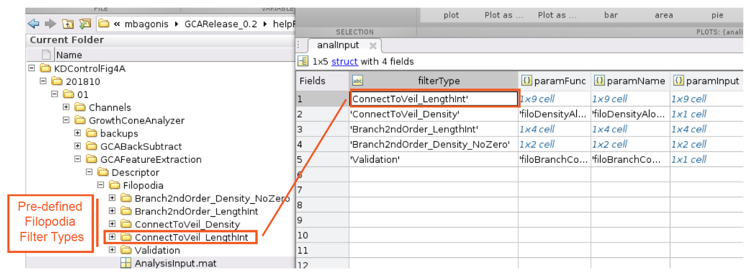

In the below example: once the ‘ConnectToVeil_LengthInt’ filter was made:

9 separate features were extracted using 5 different GCAAnalysisExtract_xGeneralFeatureType.m functions:

Note the folder name below indicates the name xGeneralFeatureType.

These IDs for the functions are located in the .paramFunc field of analInput.

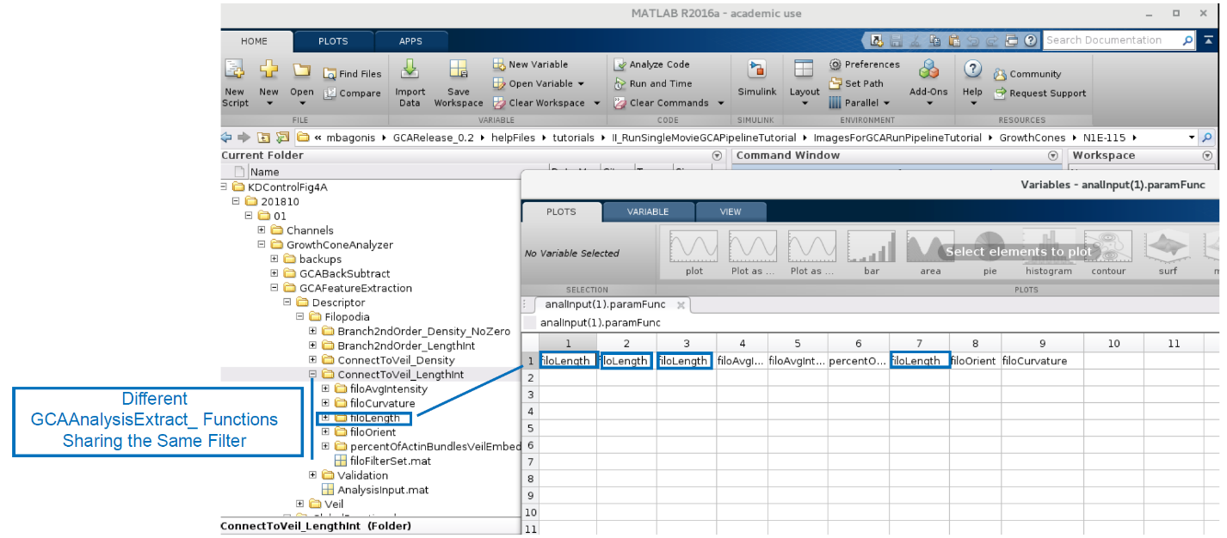

Finally the below example shows the 4 features extracted using *GCAAnalysisExtract_filoLength.m*

Each feature name is specified in the .paramName field of the analInput structure.

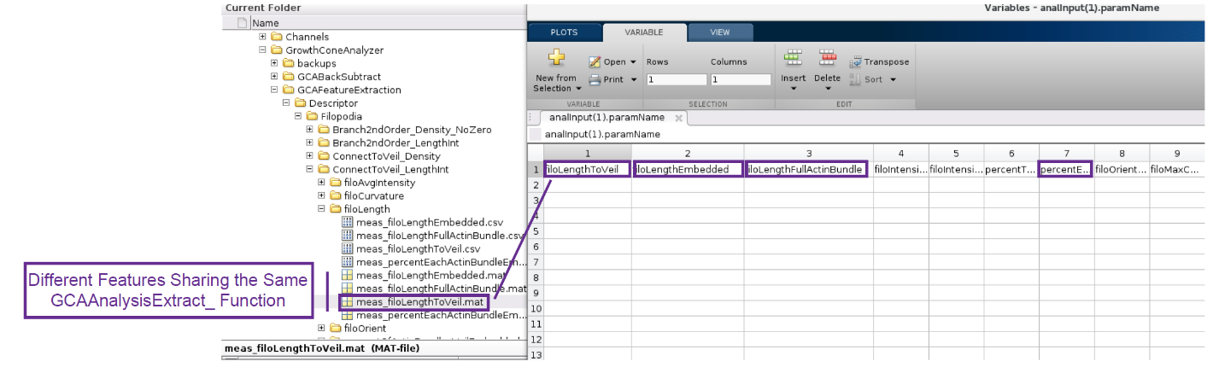

##### Generating additional Feature Visualizations

By default GCA does not generate all potential feature plots as they are often not necessary and it would be computationally very inefficient.

However, if one would like to view a feature overlay visual as in Fig. 5C-D of the GCA manuscript see **Filopodia** **Feature Overlays**

#### Output: GCAMasks

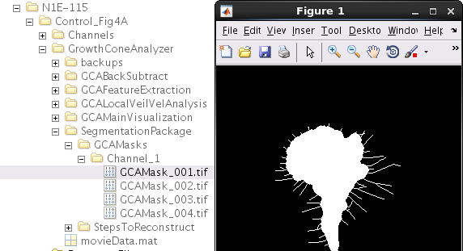

#### Output: Veil/Stem Mask

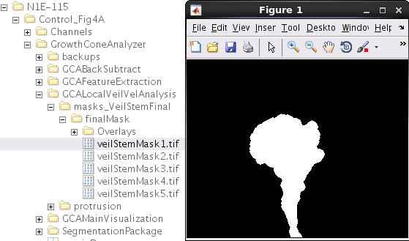

#### Output: Veil/Stem Outline

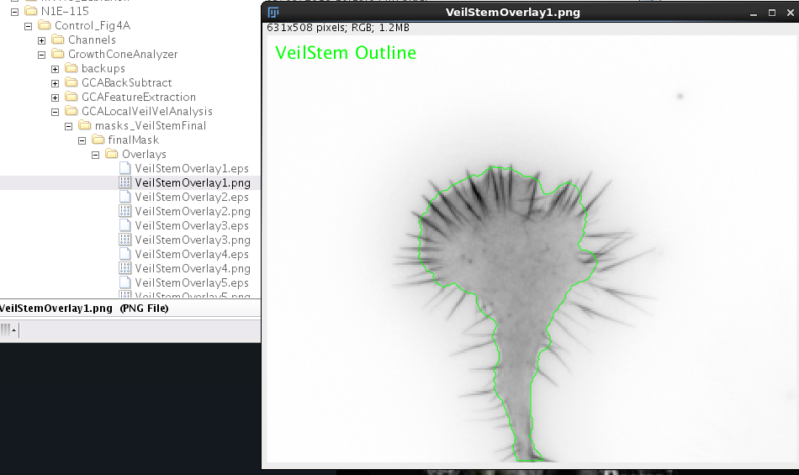

#### Output: Background Subtraction

**Overlay:**

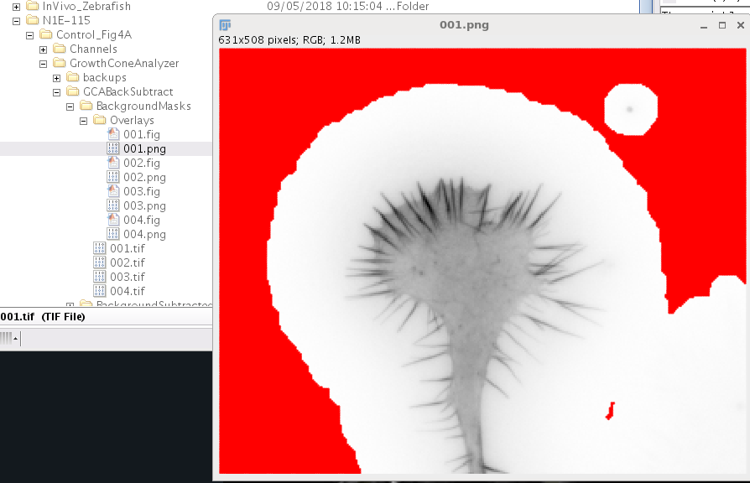

**Mask:**

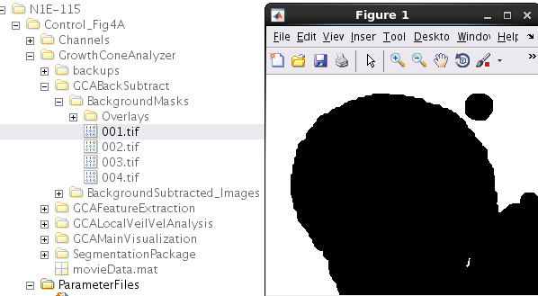

#### Output: Local Veil Velocity Image Overlays/Veil Velocity Map (CK666 treated example)

**Veil Velocity Overlays**

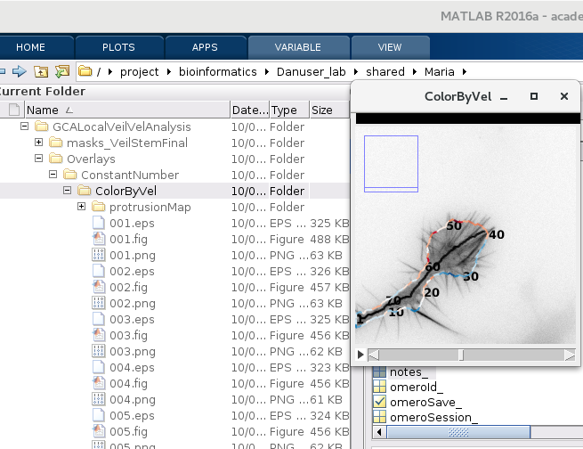

**Veil Velocity Maps**

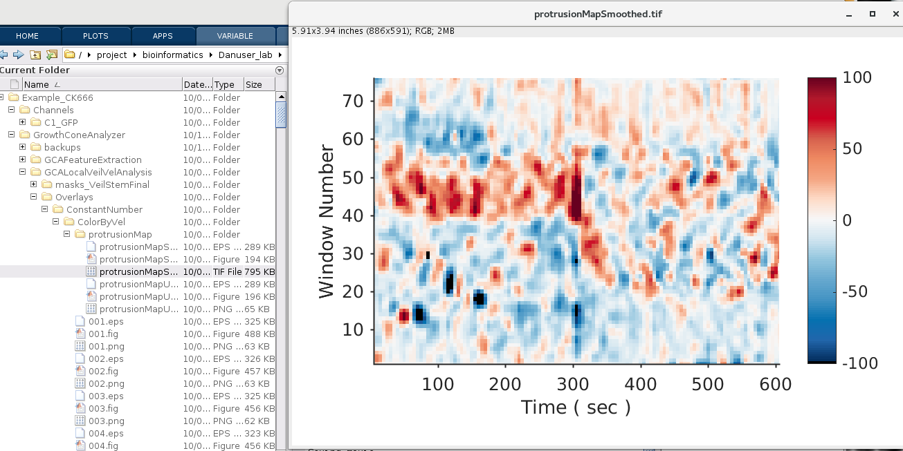

#### Output: Neurite Outgrowth State Classification (As in Fig. 7 C (ii-Right)of GCA Manuscript)

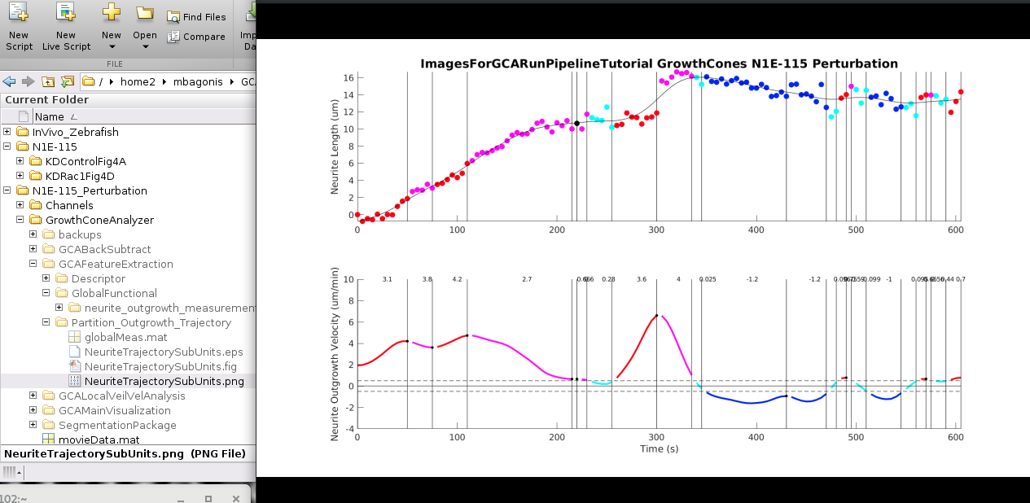

Note: globalMeas.outgrowth.stateAllFrames holds the perFrame outgrowth classification state of the respective trajectory

1: Pause (cyan); 2: retraction (blue) ; 3 acceleration (red) ; 4 deceleration (pink)

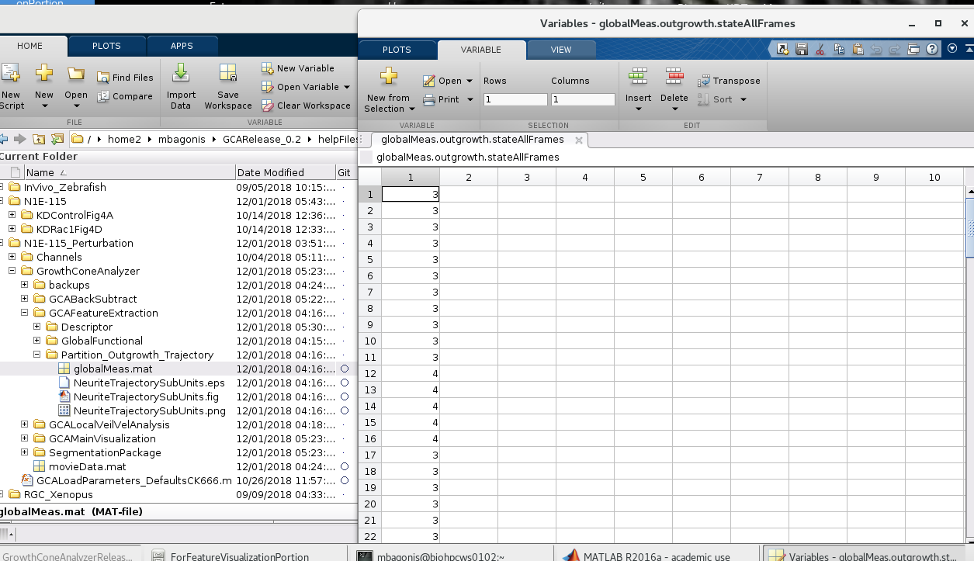

# Changing the Segmentation and Run Parameters

To change segmentation parameters:

Type:

edit GCALoadParameters_Defaults

(or any of the other parameter files to use as a template)

The function will open.

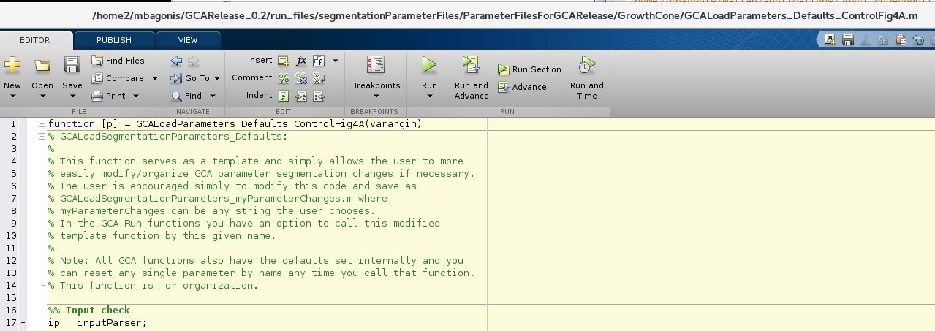

The file is partitioned into sections corresponding to different steps in the GCA pipeline, however they are compiled in a single parameter file for organizational purposes.

**You can make changes to any parameter, save your file with a unique name for posterity, and then load it when running GCARunFullPipeline (either manually or via the command line).**

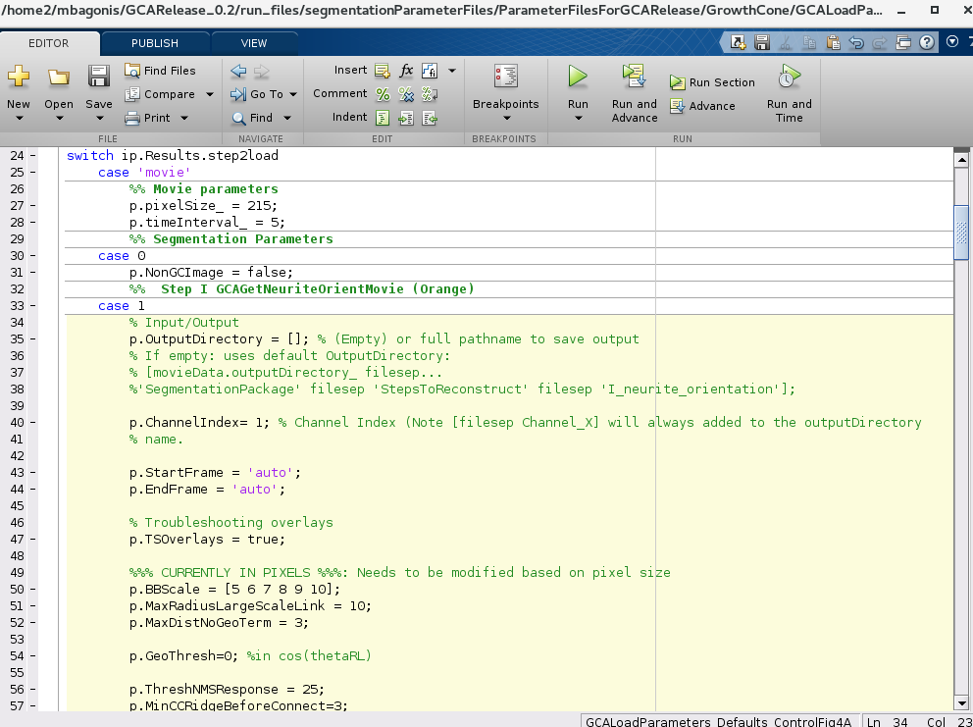

# Troubleshooting Segmentation

***(Section coming soon)***

## **Troubleshooting: Veil/Stem**

## **Troubleshooting: Filopodia Reconstructions**

## **Troubleshooting: Filopodia Fits**

(See also: Visualization: Visualization of automated filopodia linescans and endpoint localization)

# Visualization

## **Filopodia** **Feature Overlays**

By default GCA does not generate all potential feature plots as they are often not necessary and it would be computationally very inefficient.

However, if one would like to view a feature overlay visual as in Fig. 5C-D of the GCA

Type into the command line:

**GCAVisualsMakeFeatureOverlayMovie**

**The default options are designed to be relatively interactive:**

**First a box will pop up asking you to select a movieData.mat file.**

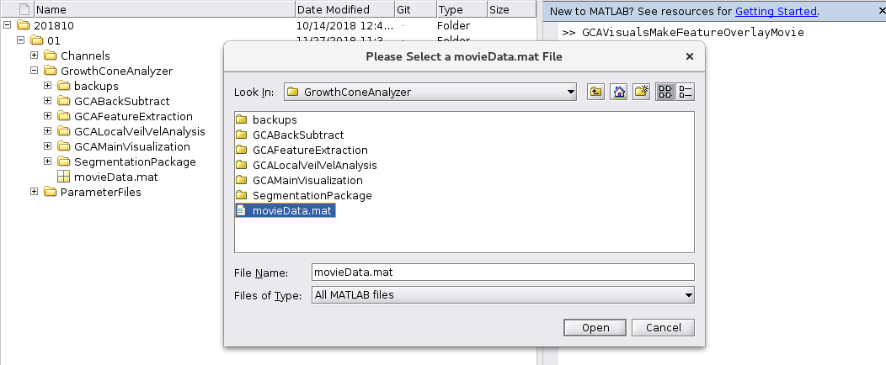

**A second box then lists all features previously extracted for that movie**

**Select the feature(s) you would like to visualize and hit the arrow pointing right (don’t worry you can always repeat this procedure if you want to look at another feature- it will just to continue to add these overlays to the appropriate folder hierarchy).**

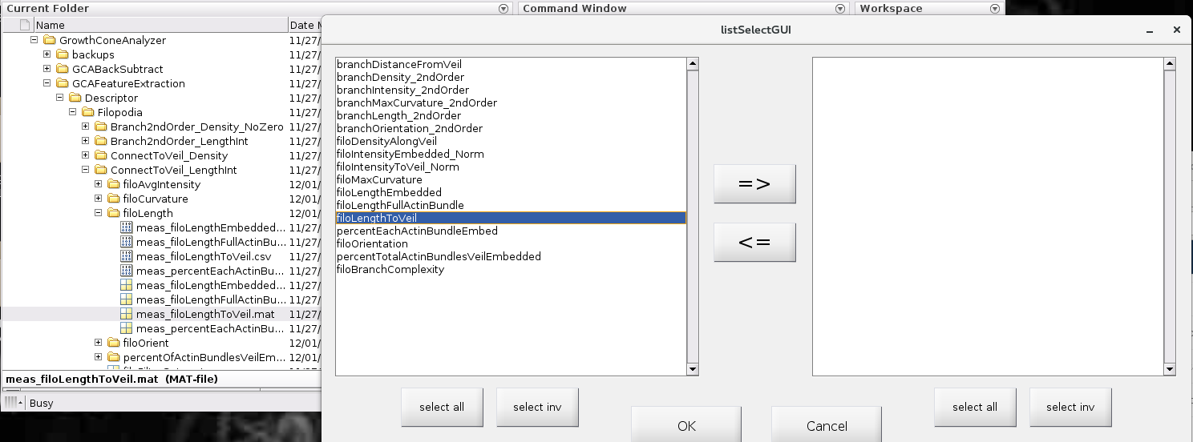

**When you are happy with your selection: Click OK:**

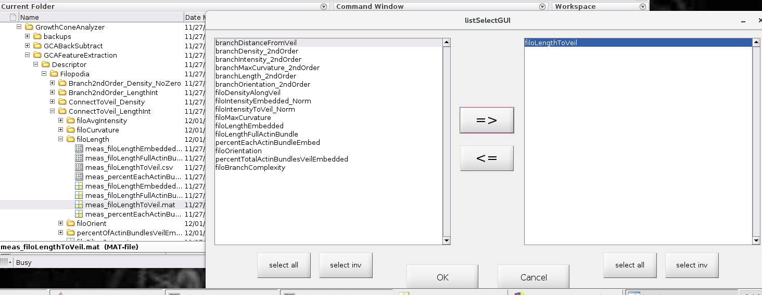

By default: Overlays of the full movie for that respective feature will be saved within the respective hierarchy in a folder named *xFeatureName*_Feature_Movie (as below). Note: feature overlays are designed not to show the entire segmentation, but only those filopodia etc used for that specific calculation (for example below overlay will not display overlays of 2nd order or greater branches)

**By default most feature plots are colored by the value of the given feature when appropriate (for example: below filopodia overlays are colored by their calculated filopodia length to veil)**

**Output of Feature Visualization Function:**

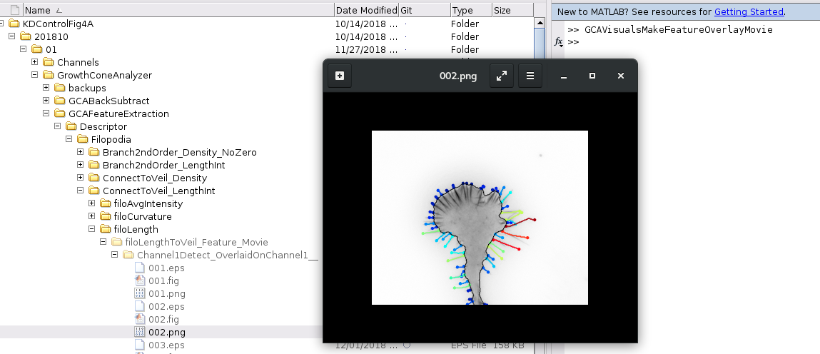

**Other overlay options are available via the command line.**

**Below provides some useful examples:**

### ExampleI:

**GCAVisualsMakeFeatureOverlayMovie(‘plotText’,true, ‘frames’,2)**

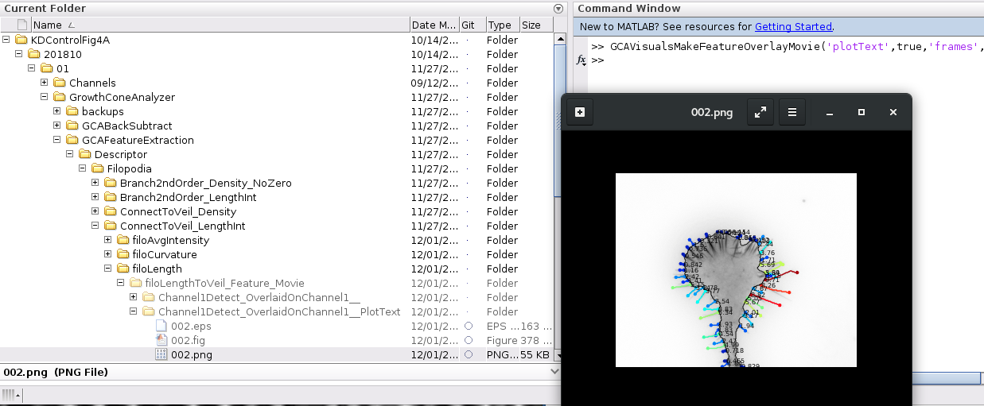

Where the ‘plotText’ parameter flags to plot the individual feature values for each filopodium and ‘frames’ parameter specifies the user only would like to plot frame 2, not the whole movie (Note: can be a vector of numbers, ‘frames’, [3,4] for example would plot both frames 3 and 4)

### ExampleII:

**GCAVisualsMakeFeatureOverlayMovie(‘plotText’,true, ‘plotIDs’,true, ‘frames’,2)** 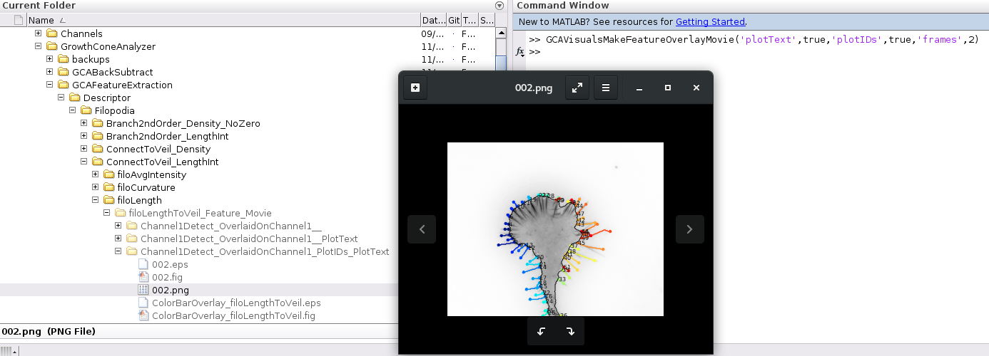

**The above command colors and plots the filopodia by their respective segment ID (pre-filtering)**

**Within the larger filoInfo data structure.**

### Example III:

**GCAVisualsMakeFeatureOverlayMovie( ‘frames’,2)**

If you choose here all features with the above command, it will make the respective visualization for Frame 2 for each feature.

**Hit *Select all***

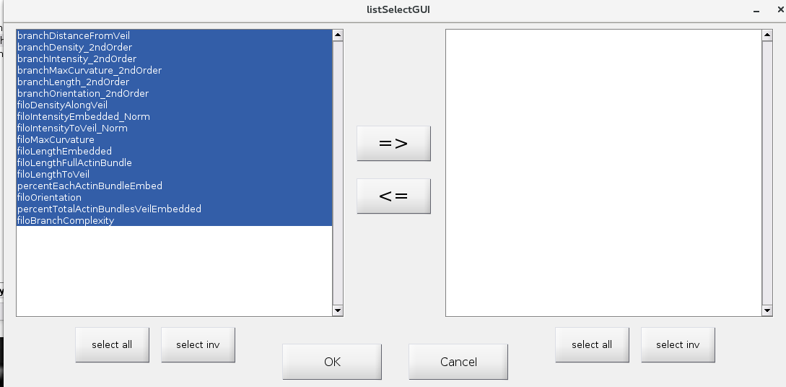

**Hit Right Arrow**

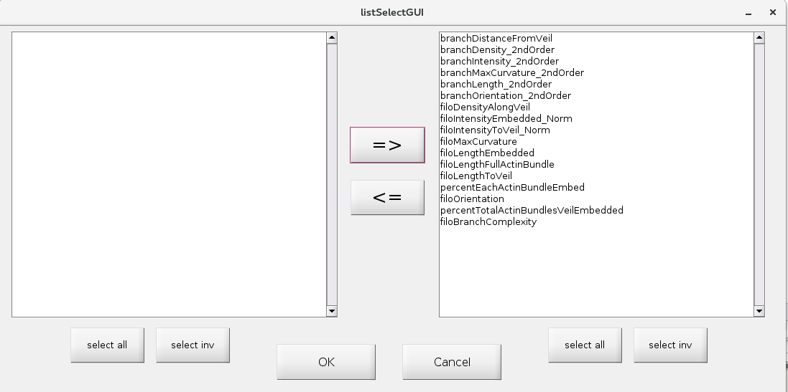

**Click OK**

**Respective feature plots for frame 2 should now be saved to their respective folders.**

**(Below shows an example of the 2ndOrder branch length feature)**

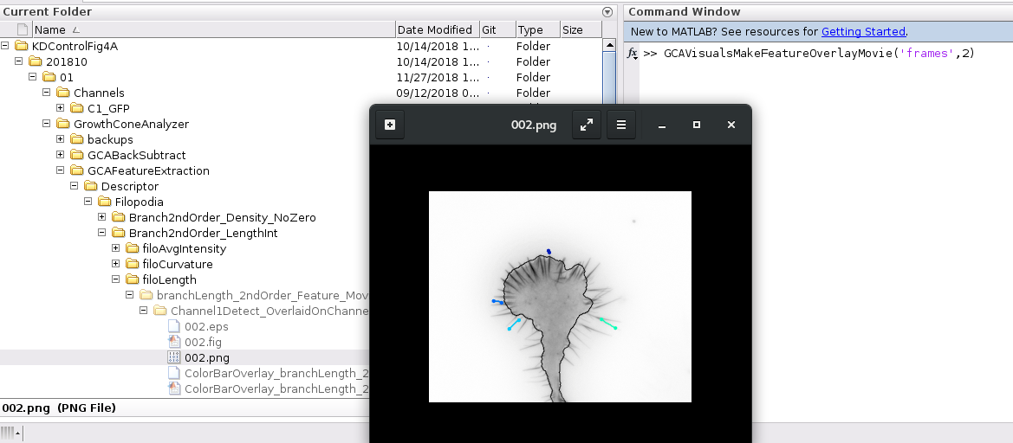

**(Below shows an example of the percentEachActinBundleEmbed Feature Overlay)**

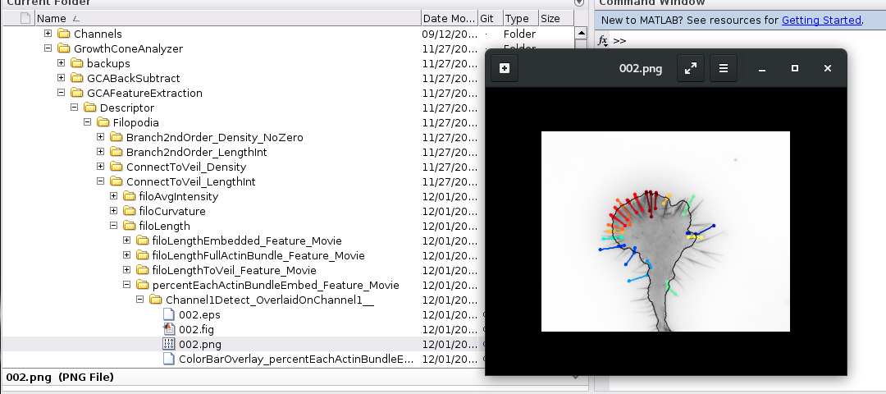

## **Veil/Stem Feature Overlays**

***(More Information Coming Soon)***

## **Visualization of automated filopodia linescans and endpoint localization**

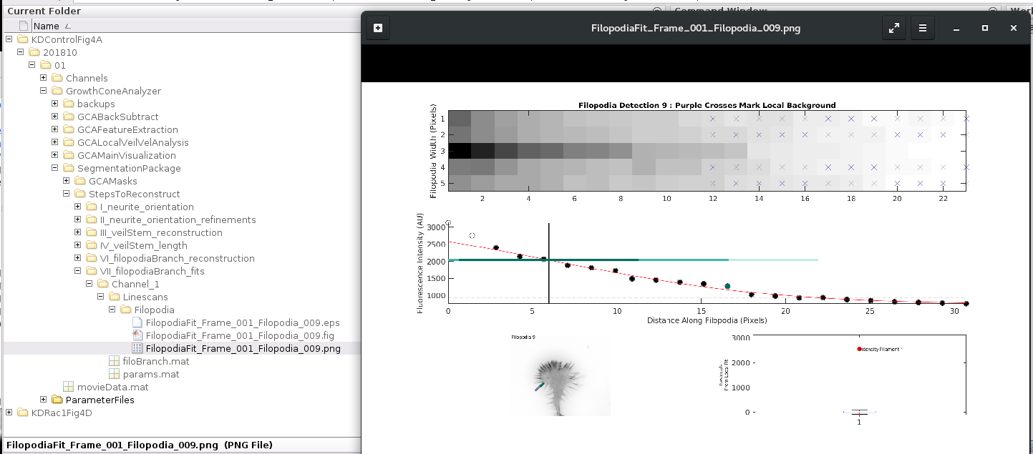

**Type:**

**GCAInteractiveExamineFilopodiaFit**

in the command line.

A window will pop up to ask if you would like to view the filopodium decay.

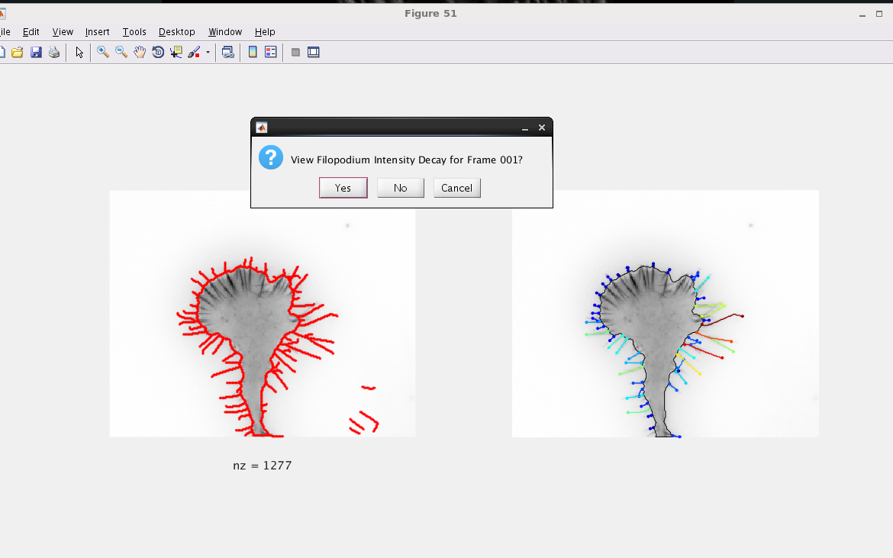

One can click on the left image (the filopodia/branch detections pre-fitting- the right image post-fitting/filtering is for reference).

A figure with information for that filopodium as shown in Figs will pop up:

The user can save this information or continue exploring the fits.

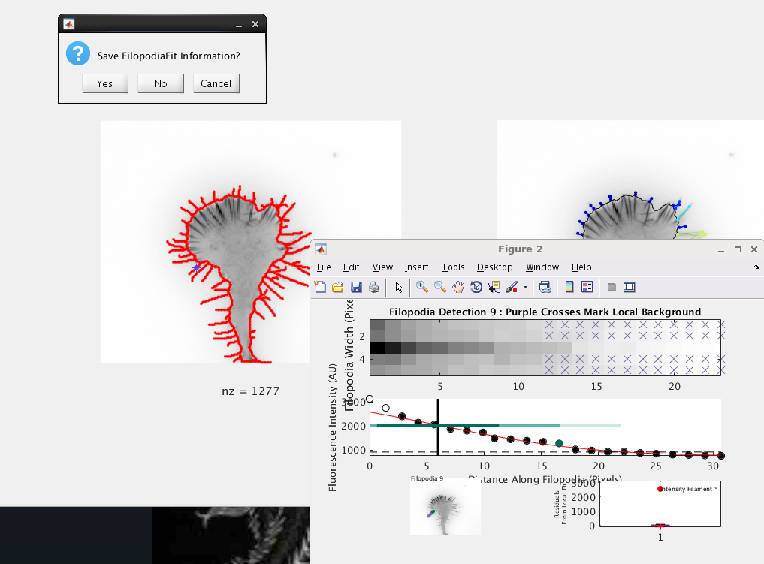

**By default: any fitting visuals will be saved in …StepsToReconstruct/VII_filopodia_fits/Channel_1/Linescans/Filopodia/**



# Grouped Feature Extraction and Comparative Analysis Tools

To perform a final analysis one ultimately needs to:

I) Exclude movies that have either been manually or computationally flagged for egregious errors.

II) Group your data by a treatment condition.

III) Pull the relevant feature data for plotting, stats, and higher order analyses.

While one can build their own workflow

GCA does include several group analysis tools.

**In GCA the crux of a group analysis is a gcaGroupData.mat file.**

**The Group Analysis functions in GCA let you**

I: Initiate a data structure specifying a select group of movie paths for the final analysis (GCAGroupAnalysisCreateGroups.m)

II: Collect feature data from these analysis folders into a single .mat file for easy storage of a final dataset (GCAGroupAnalysisCollectFeatureDataForStats.m)

III. Visualize the collected feature data/save plots and .csv files. (GCAGroupAnalysisGroupPlots.m)

## **I) Initiate a grouped feature data analysis file**

(ie specify the grouped movie paths to be included in the analysis)

Type: **GCAGroupAnalysisCreateGroups**

Into the workspace select the main directory where your grouped movie data structure is located. (Below shows an example using the N1E115 data from Tutorial II)

(The folder directly above each of your group data files).

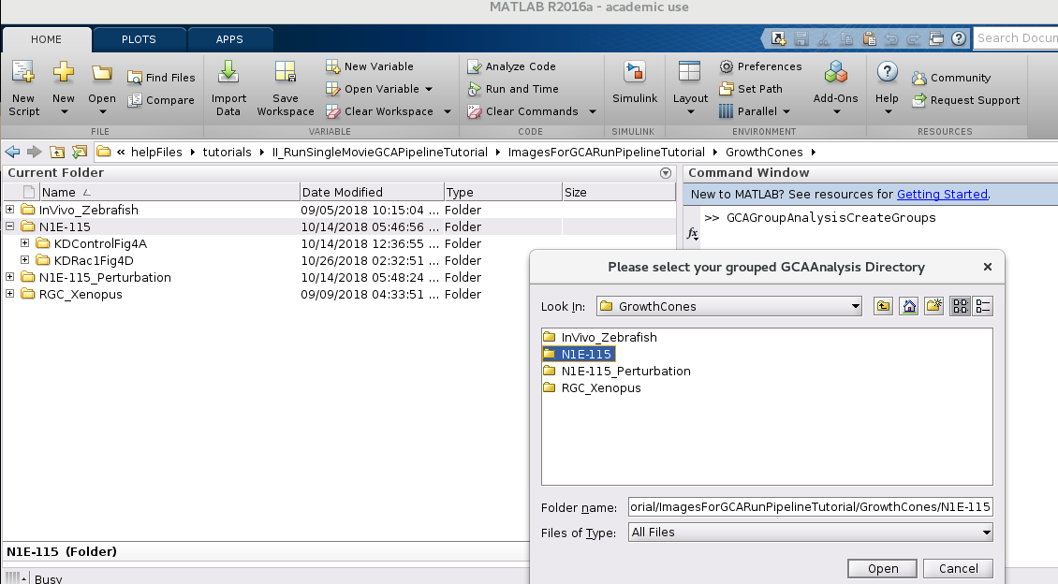

**Click a directory to save your final output file.**

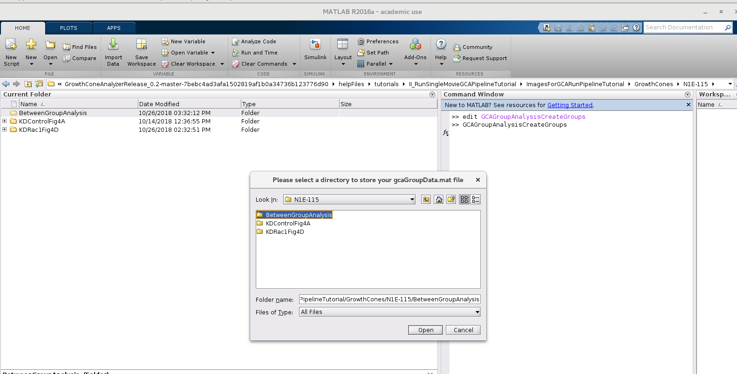

Select which groups of data you would like to analyze: (Note Currently the grouping function assumes the data structure described in **Preparing your data for GCA Analysis**.

**Select Groups and hit right arrow:**

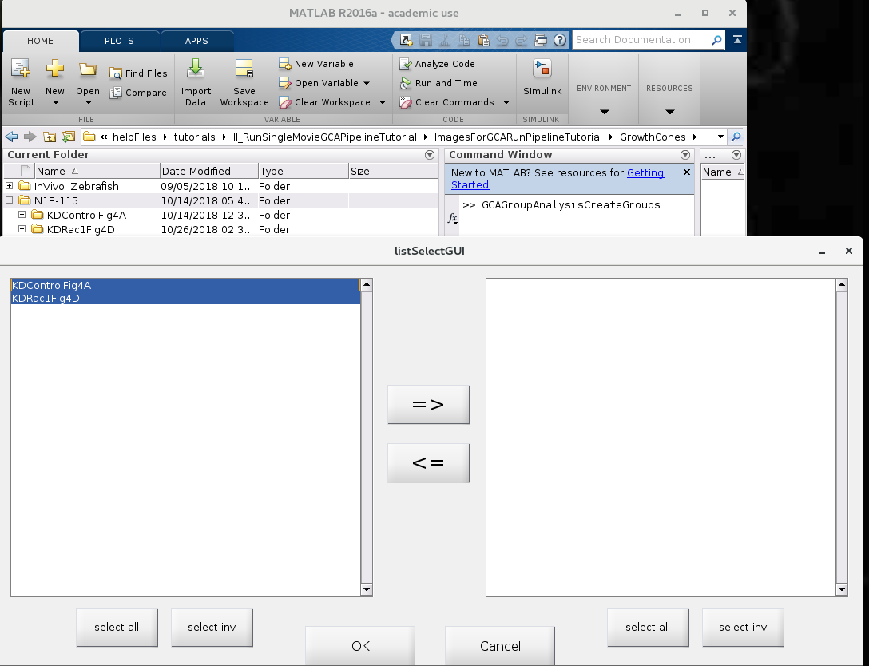

**Groups Selected: hit OK**

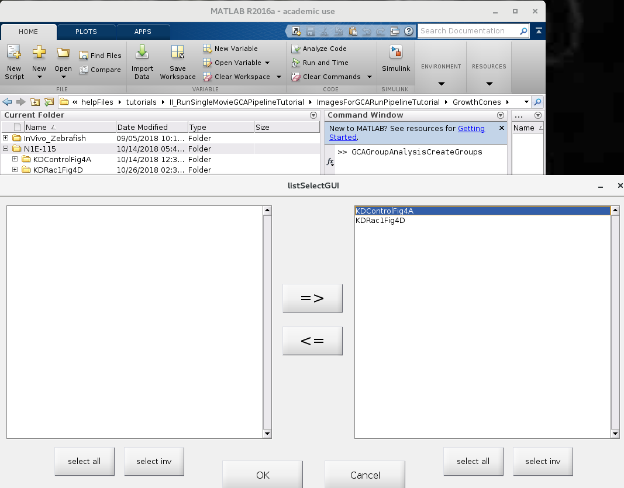

**The output will a be a gcaGroupData.mat file with a single field .info**

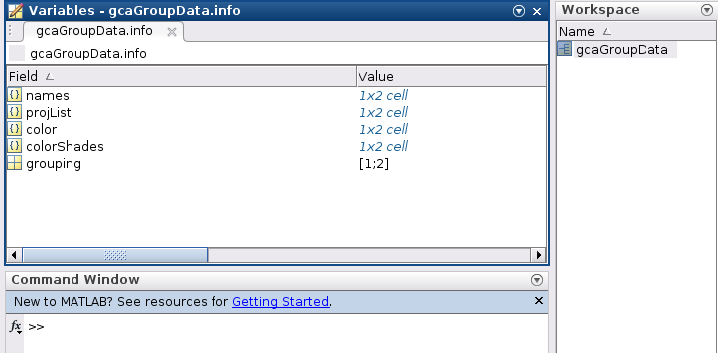

This info field simply saves some useful information regarding the group names (.names), the movie analysis paths and movie names (.projList), the colors to assign each group for plotting (.color/.colorShades), and useful group indexing vectors (.grouping).

(For more details regarding the format of the gcaGroupData.mat output visit the comment section of this function by typing:

edit GCAGroupAnalysisCreateGroups.m)

## **II) Collect feature data from the movie paths you specified previously and save them in your gcaGroupData.mat file.**

Type **GCAGroupAnalysisCollectFeatureDataForStats** into the command line and select your gcaGroupData.mat file you created in Step I

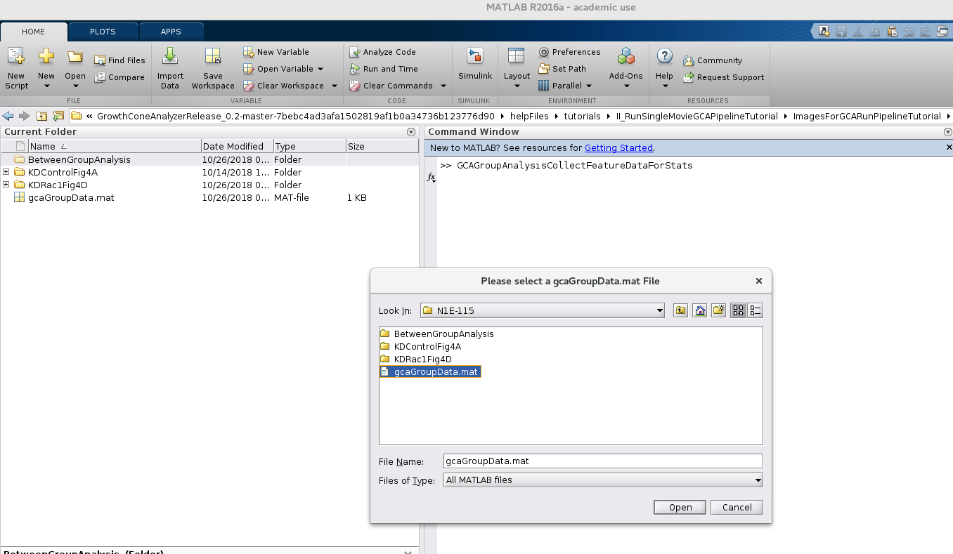

**Select an Output Directory to save your new gcaGroupData.mat with feature data collected.**

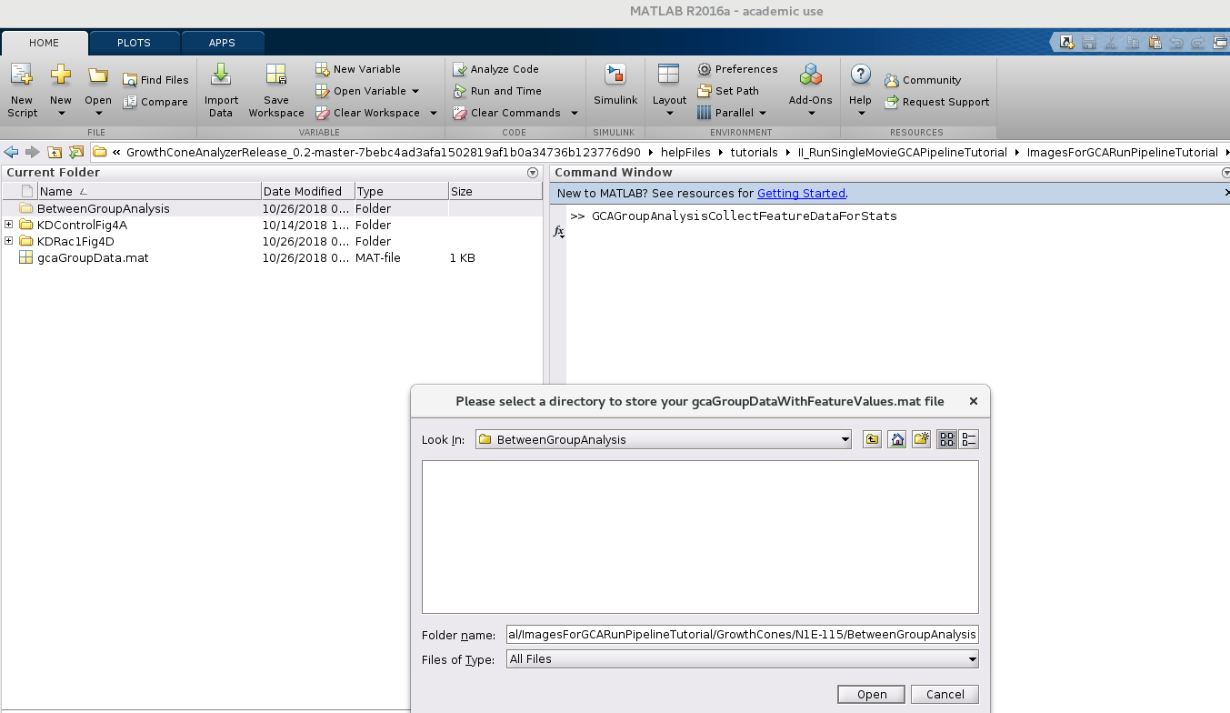

***GCAGroupAnalysisCollectFeatureDataForStats.m*** will by default look in each ‘GCAFeatureExtraction’ folder for all ‘meas_XFeature.mat’ cell array files and collect/reformat those data for grouped analyses and plotting. See GCA Output: Feature Data

**OUTPUT:**

**If you load the gcaGroupData.mat file into the workspace you now should still have the .info field AND all other collected feature data found added to the file.**

Each gcaGroupData.dataMat is comprised of a 1xnGroup cell array

Where in the default case, each cell is a padded nFeature Values (rows) x nMovie (column) cell array for each group of data. (Note each matrix is padded with NaNs (notANumber) to make the matrix symmetric).

**Examples:**

gcaGroupData.filoLengthToVeil.dataMat{1}(:,1) for instance is data collected from [gcaGroupData.info.projList{1}{1,1} filesep ‘GCAFeatureExtraction’] for the feature

‘filoLengthToVeil’

**(ie) Group 1 (KDControl), Movie 1**

gcaGroupData.filoLengthToVeil.dataMat{2}{:,1) is data collected from

[gcaGroupData.info.projList{2}{1,1} filesep ‘GCAFeatureExtraction’]

(ie Group2, Movie1)

## **III) Explore your grouped feature dataset: make comparative plots, export collected data as .csv files, and run simple statistics for select feature data.**

### Example I: Make plots/of the data you collected for N1E-115 test images above

**Type GCAGroupAnalysisGroupPlots** in the command line

**And load any gcaGroupDataWithFeatureValues.mat file**

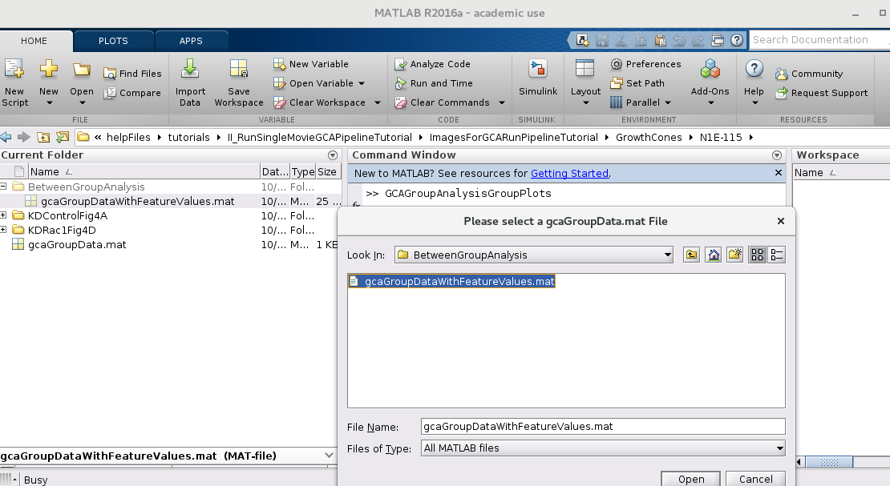

**A ListSelect GUI will appear: select the features you would like to examine (don’t worry you can always examine other features or the same feature again later).**

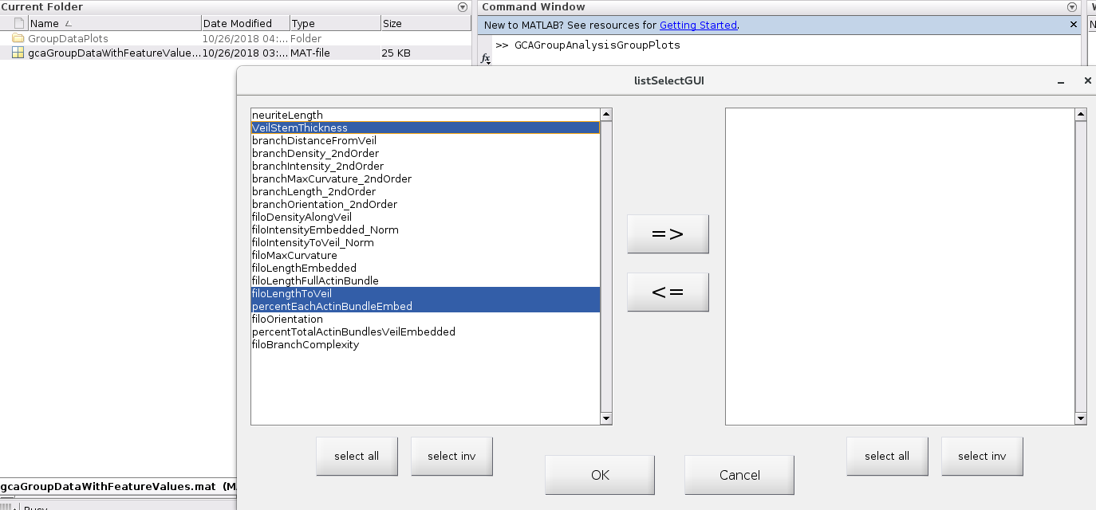

**Press the Right Arrow:**

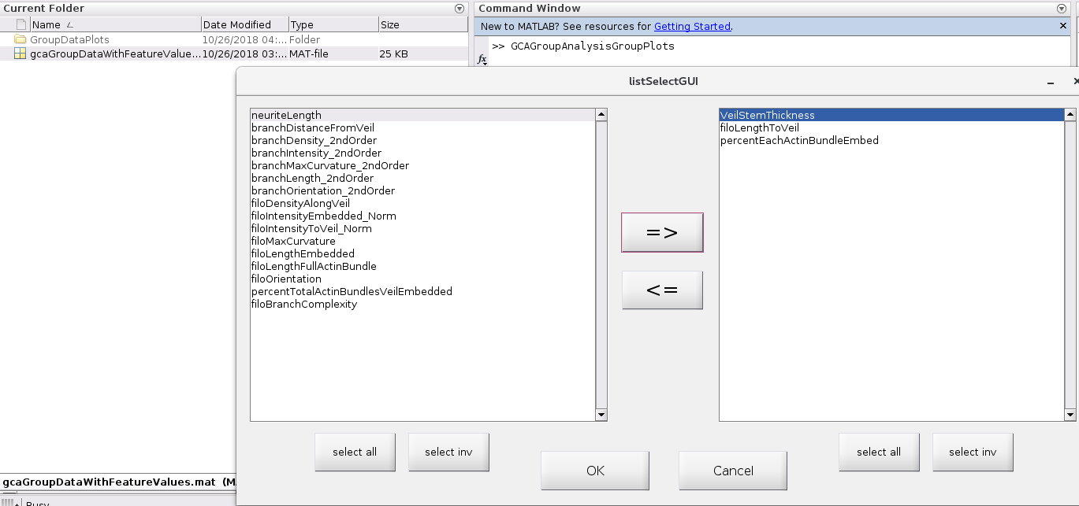

**Select which type of plot you would like to examine (in this case since there is only one movie per group doing stats per movie (cell) does not make sense. Used the pooled option**.

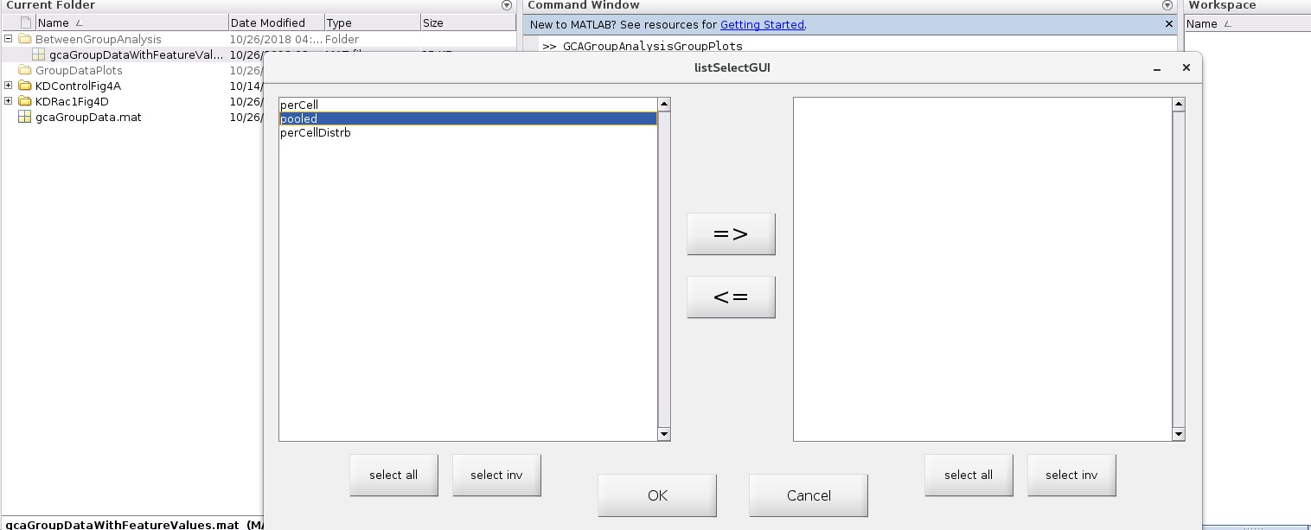

**Example I Output: pooled plots for each feature selected.**

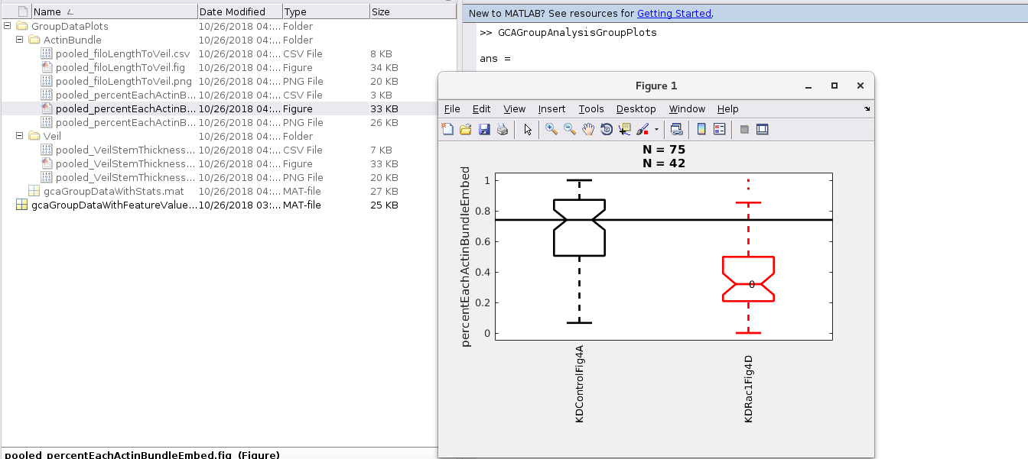

N here for pooled is the number of measurements included per group (pooled over multiple movies) For a quick view of stats the control vs. perturbation p-value is overlaid on the perturbation plot.

**Example I Output: corresponding feature .csv file**

Contains all the raw feature data for export into any other statistical program.

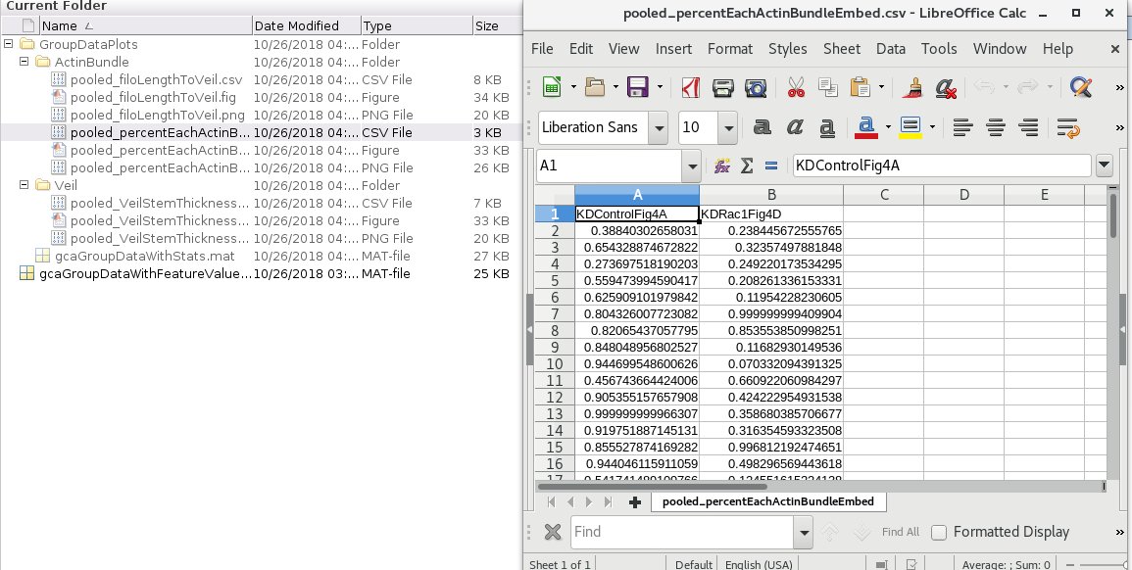

If you ever want to explore any other feature or view the same using a different plot type just repeat the above steps.

### Example II (Reproduce Fig. 7A (left) Manuscript)

Type: GCAGroupAnalysisGroupPlots

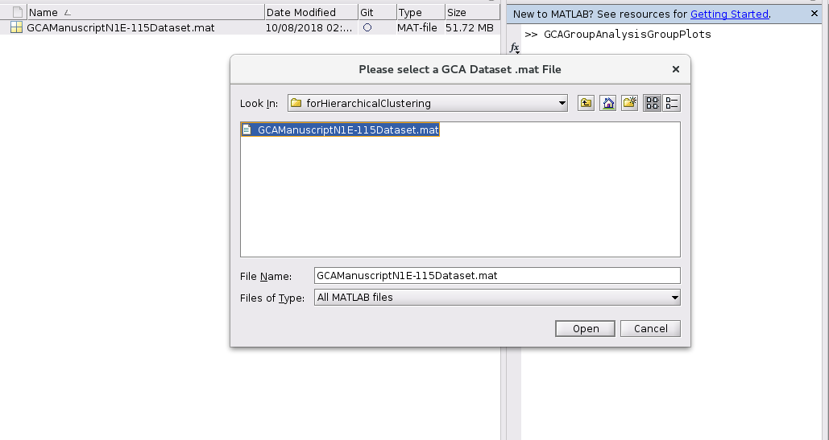

**A list of all the features collected in that dataset will pop –up: select filoLengthToVeil**

**and press OK**

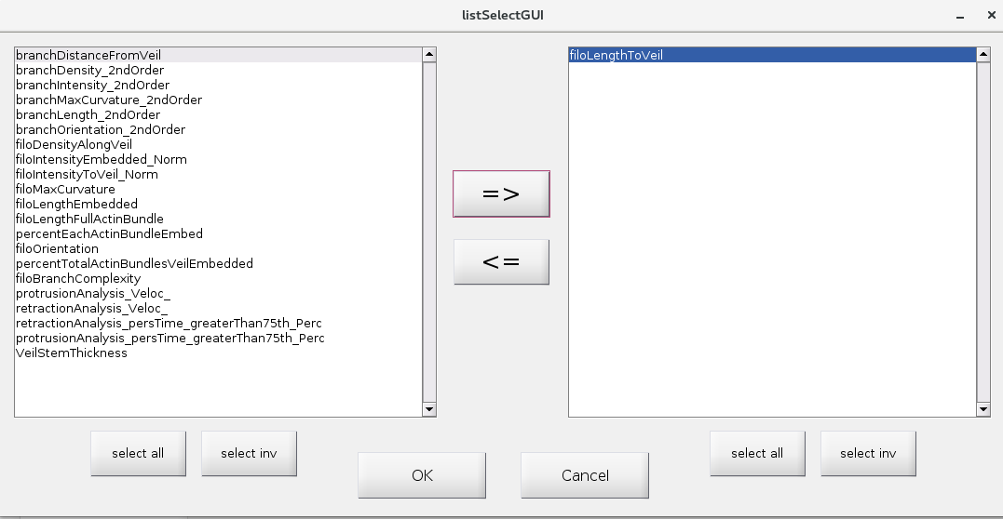

**Per Movie (Cell) Plot**

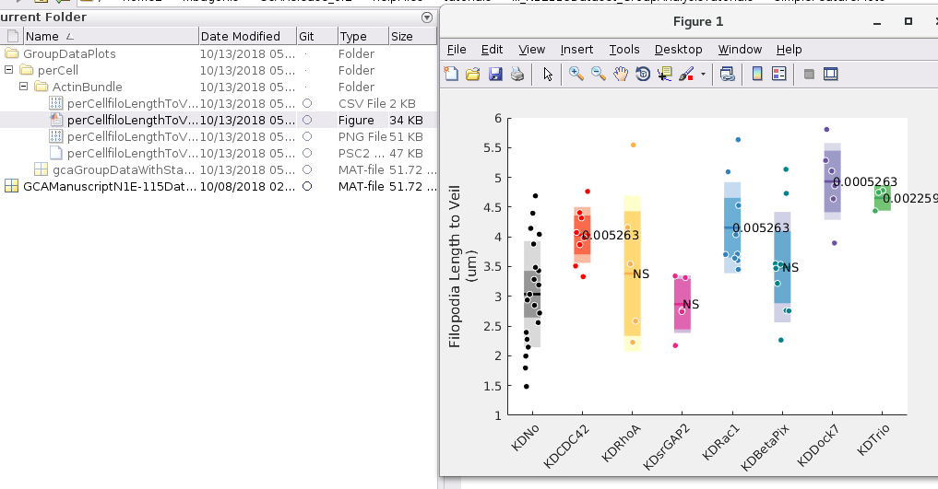

**Corresponding .csv file of data**

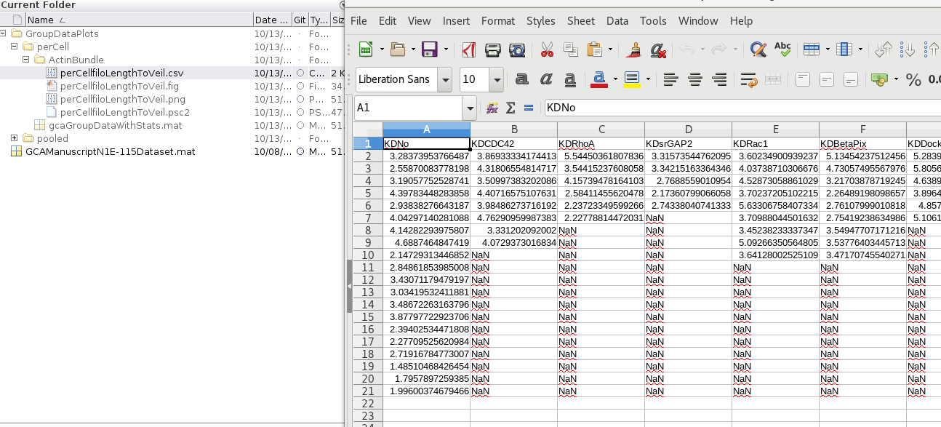

## **IV) Hierarchical clustering of grouped feature data**

**(Reproduce Fig. 7A (right) in GCA Manuscript)**

**I. Type:** **GCAGroupAnalysisHierarchicalClustering**

Into the matlab command window

By default a dialogue box will open asking you to a gcaGroupData.mat file.

Load the pre-run GCAManuscriptN1E-115Dataset.mat included with the release.

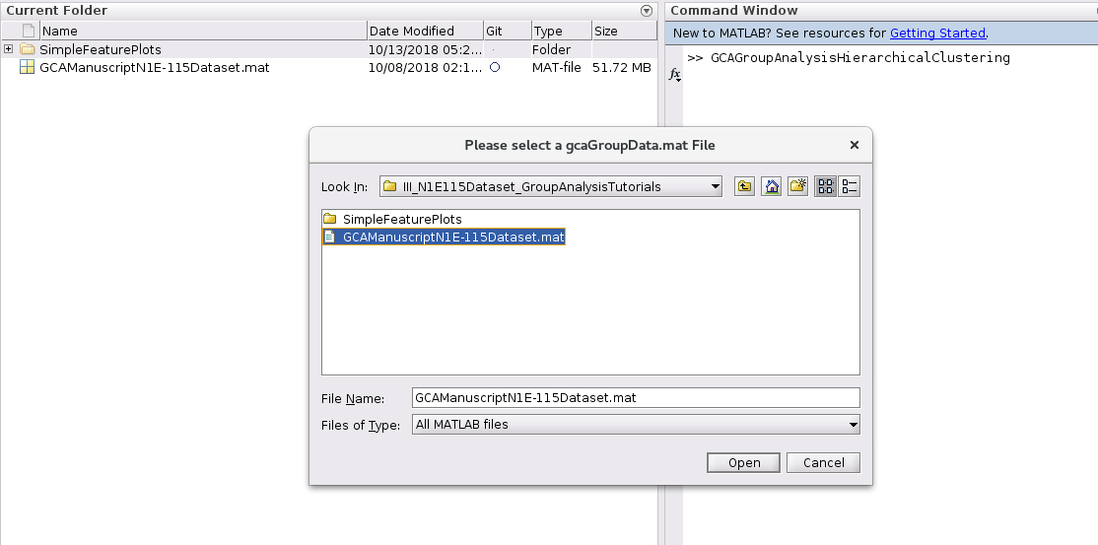

**II. Once loaded a dialogue box will pop up detailing all of the features already extracted for that specific gcaGroupData.mat files**

Click on all the features you want to include in the hierarchical clustering (for this analysis we select all of these) and then hit the **right arrow.**

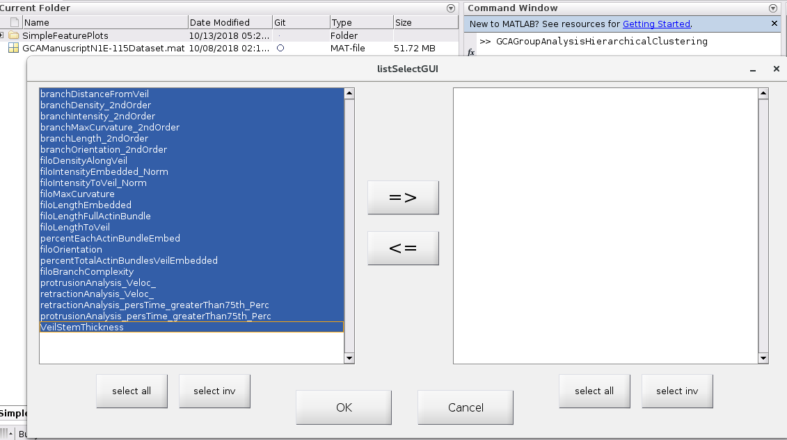

**All features selected**

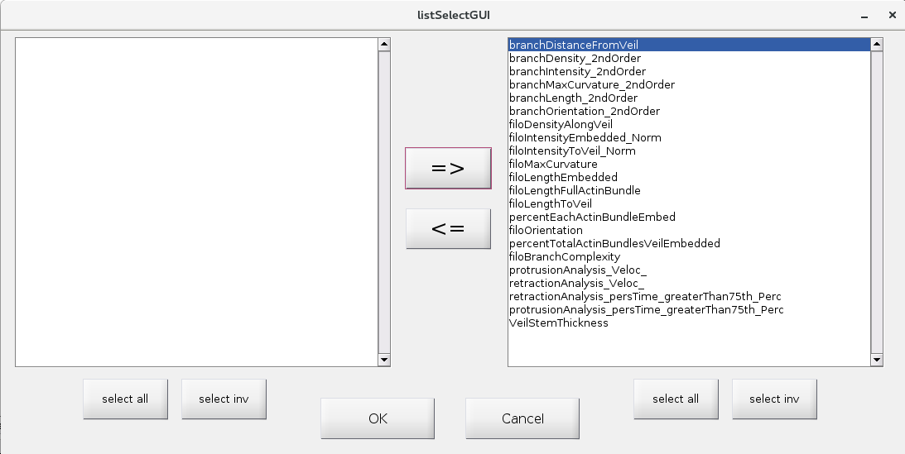

**Default output is a Hierarchical Cluster Folder including the clustergram.mat object.**

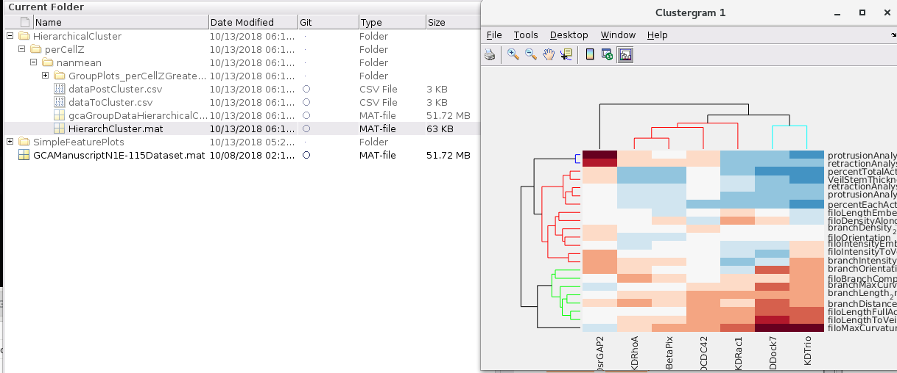

**And a .csv file of the difference metric post clustering**

